PROPOSAL TO NOMINATE AN EHRP ITEM OF INTEREST

Tacky Creek Bridge

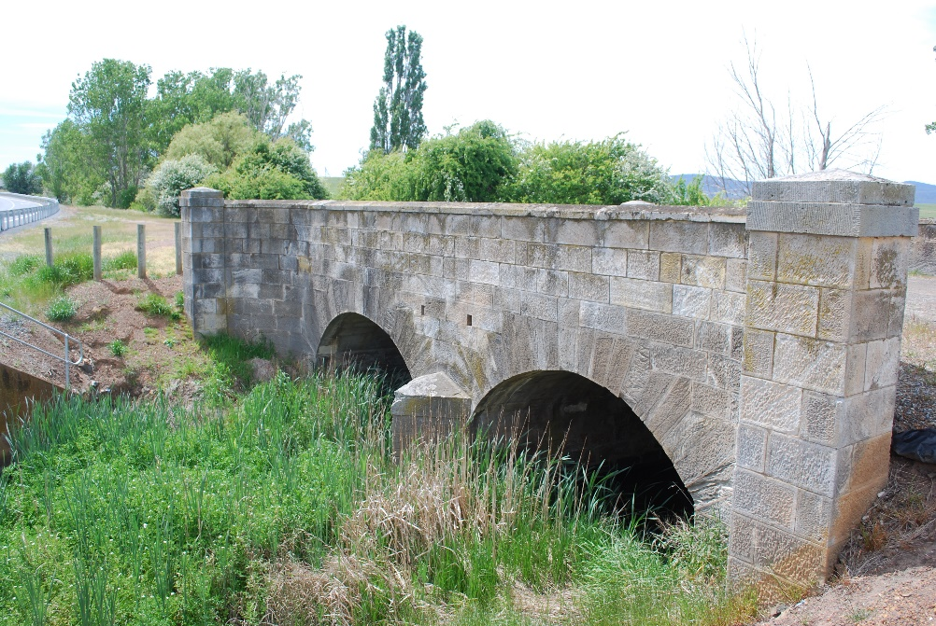
Western Bridge Elevation
(Photograph taken by Graeme Nichols)

Item Name: | Tacky Creek Bridge
Other/Former Names: | Tacky Creek Bridge
Locality: | Northern approaches to Ross
Address: | Chiswick Road
Co-ordinates

Nominated by: | Graeme Nichols
Contact Ph. & Email: |  |  | graeme.nichols@bigpond.com
EHA Branch: | Tasmania
Current Owner: | Department of State Growth
Original Owner: | Lieutenant Governor of Van Dieman’s Land
Current use: | Preserved bridge, not in use
Former use: | Bridge serving the Midland Highway
Proposed use: | Preserved bridge
Item Condition: | The bridge is sound and well constructed with no foundation settlement. There is serious delamination and fretting of stonework on the eastern upstream face of the bridge (Fabric Report by Peter Spratt).
Designer: | Captain Alexander Cheyne
Builder: | Convict work gangs under Captain Cheyne
Started: | 1836 | Completed: |  | December 1836
History:  (100 to 600 words) | During a visit to Ross in 1836, Lieutenant- Governor Arthur witnessed the difficulty and danger travellers experienced crossing Tacky Creek. He instructed Captain Turner to erect a temporary timber bridge across the creek. This bridge quickly fell into disrepair.  In July 1836, Mr Horne, the owner of local property Chiswick wrote to the Colonial Secretary petitioning him to build a permanent bridge across Tacky Creek. The Captain Alexander Cheyne, allocated four masons, who had previously been employed on Ross Bridge, to construct Tacky Creek Bridge.  In 1880 the bridge was repaired following damage caused by flooding.  In 1921 and 1953 the stonework was repointed, particularly the pier and abutments, and the crown of the arches. Additionally, in 1953, new stones were cut to replace those shattered beyond repair.  (Reference: Tacky Creek Bridge: Historic Report by Lindy Scripps 1996)
Description:  (100 to 600 words): | Tacky Creek Bridge is a two span arch bridge approximately 10.7 in length. The arches are divided by a stone pier with cut-water ends. At road level the bridge is distinguished by stone parapet walls on either side and these have slightly curved ends.
Engineering Significance:  (Refer Section 2.4 in ‘An Engineer’s Guide to the Conservation of Australia’s Engineering Heritage’) | Convict built two span stone arch distinguished by stone wall parapets with curved ends.
Webpage Summary:  (200 to 300 words) | Tacky Creek Bridge is a convict built two span stone arch bridge approximately 10.7m long built in 1836. The bridge is distinguished by stone wall parapets with curved ends. The bridge is believed to have been designed by Captain Alexander Cheyne later the Director of Public Works.
Engineering Theme | Heritage Bridges
Heritage Listing:  (State and/or Local Authority) | Registered on the Tasmanian Heritage Register, THR Reference 10013

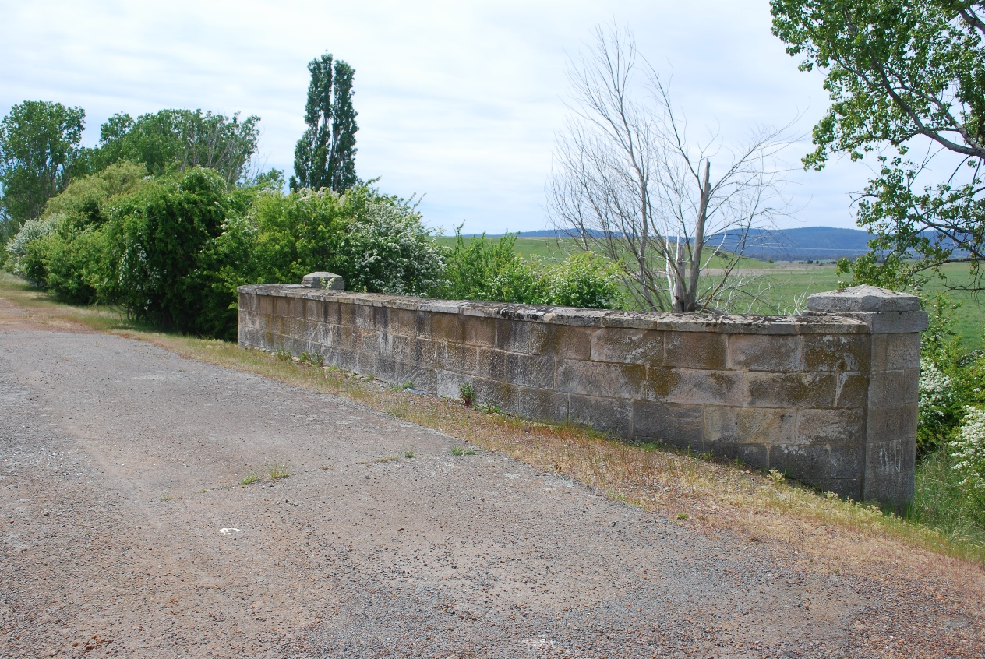

Photograph 1: Stone parapet wall on the eastern (upstream) side of the bridge
(Photograph by Graeme Nichols)

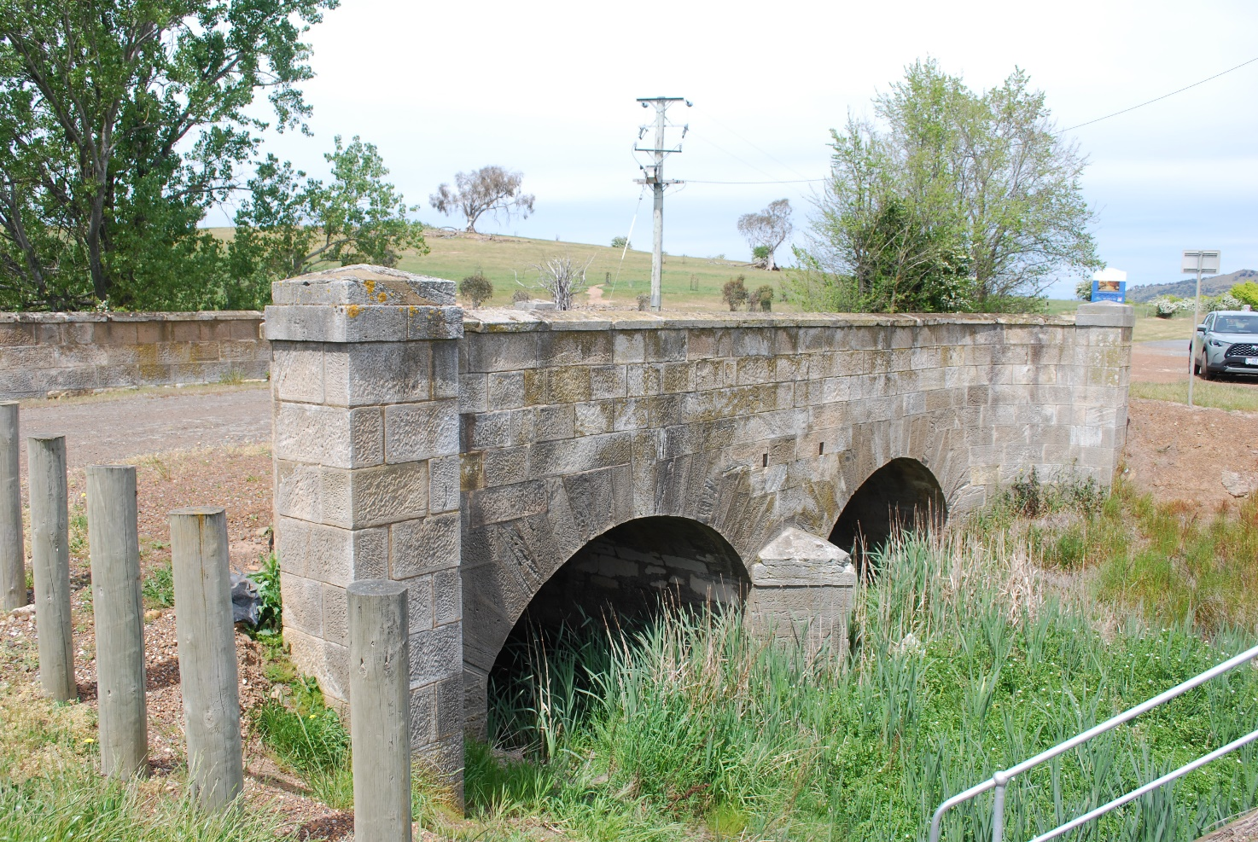

Photograph 2: Western (downstream) elevation of the Bridge
(Photograph by Graeme Nichols)

