In loving memory of my husband, Sam,

my parents, Zipa and Zalman Mordecai

and

for the enjoyment of my children

Miriam and Leonard Dorothy and Martin Daniel and Eleanor

and my grandchildren

Allen Howard Ronna Beth Barry
Larry

Caren Shelly Kenneth David Steven Charles

CONTENTS

Introduction: Keep on writing, please

- Life in the shtetl

Long winter nights in Russia

Summer in Russia

- My first love: Levi

- Max and Sam leave Russia

- The Revolution of 1917
s. Lillian--the teacher: 1920
6 • Fifel: 1921

- Preparing to Leave Russia

- The Polonia: 1923

- It was a very good year

- Castle Garden

- The best years of my life

l 2 • Sam and I are married: 1925

- Wyandotte, Michigan

- Miriam, Dorothy, and Daniel This is not my son
The Miracle: 1936
- The grandchildren Ken's Bar Mitzvah Ronna and Larry
- Naches and Tsores

l 7. Mazel-Tov

18. Ain Karem: 1965

l 9 . | Syosset, My second home: 1975
20. | Happy Birthday: July 4, 1975
21. | Sunday, March 4, 1979
22. | The Magic Box--the mailbox
23. | Graduation
24. | My Lake
25. | Mother's Day
26. | Let's Pretend
27. | Television: The Magic Box
28. | My Mother Lives in Miami Beach
29. | Love is Better Than Hate
30. | The Golden Years--The Broken Dreams

Introduction:
I don't think of myself as a writer. It is hard to write a life history because one cannot always express all the episodes that occur in one's life. You have to omit so much of what happens in life. You cannot tell the bad happenings because you are trying not to remember what happened. Maybe it happened to somebody else. So you pick the happy occasions and pretend the unhappy ones did not occur.
A great writer I am not. I started to write for my grand­ children. Children and grandchildren are anxious to know their heritage. I am one of the fortunate immigrant mothers--
grandmothers--who lived to be able to tell the story in detail. I tell the story of my survival and how we came to America.
I write just to keep myself busy and to express myself...to gather my thoughts....to spill it out.
I didn't know how to write when I was younger. I didn't
have the time. My advice, especially for grandmothers, is to start to write for your children. It will give them the best gift of all.
My children and grandchildren said, "Keep on: writing, please." So I wrote.
Life in the Shtetl
That I was born is a fact; but when I was born, I really don't know. It was probably about 1900. When I came with my family to the United States ori July 4, 1923, I gladly accepted this as my birthdate.

-2-

I was born in a clayn (little) shtetl in samotevich, Russia. Samotevich was in the state of Mogelcrb. About 500 families lived there.
Our own family consisted of six brothers and two sisters. I was the third born child, with two brothers born before me. Parents were not the happiest when a girl was born because it was harder; you had to start as soon as possible to save for her dowry. But when a boy was born, there was rejoicing.
They put a record of his birth in a Bible to know his Bar Mitzvah day. Girls were considered a big disadvantage.
My mother, Zipa Chafkin, was a very beautiful woman.
She was 5' 3 " tall and had an oval face, big brown eyes, and long black hair. She was a pillar of strength and was respon- sible for raising the children. My father, Zalman Mordecai, was born in Samotevich to a family of five brothers and five sisters. His father, a Talmudic scholar, sent him to the Yeshiva. He was a handsome, pious, and good hearted person.
Ile would give his last ruble to the needy. In business, he never asked if you had money. If the customer paid, it was alright; if not, it was alright, too.
After my parents' marriage they set up their housekeeping in a home my father's father gave them for a wedding present. My Zaydy, Bobe and family moved to a big city, Novomoskovsk.
My Bobe was married at the age of 15. Iler parents selecteJ her 1 7-year-old husband because he 1vas a pious me.n. 
not see each other until after the ceremony. Zaydy ruled his.. wife and family like King Lear. When one of his dauqhtcrs was engaged to a musician, he disowned her. Bobe
was not allowed to go to her wedding or visit with her because

she disgraced the "mishpocha" by marrying a musician. We were concerned with "yikhes" (status), and a musician was be­ neath our social class.
Love and respect are the main ingredients in married life.
This love and respect never ex·isted in my parents' life, un­ fortunately. Arguments and quarrels were a daily occurrence
in the family. This was true of the majority of shtetl marriages. Life was hard and painful. Families just existed, not knowing from day to day whether they would survive.
our village was surrounded by four villages. We were in the middle. In the middle of the street--across from our house-­ was a big well which was used by everyone on the street. Water was carried in big buckets.
In general, the life of a girl was not the happiest.
There was a shortage of men because of lot of boys were killed by wars and pogroms. There was too much competition from other girls. The girl that was born to a rich family was able to get married without any difficulty because she had a dowry.
The more money she had, the better man she was able to marry. The boys depended on the dowry to be able to start to make a living after marriage. The typical dowry was about 300 rubles. With that sum of money they were able to open a little store in the main business district. The majority opened grocery
stores and sold flour for bread, cold herring, salt and kerosene. Other stores sold dry goods--ready-made clothes or material.
Some orphan girls were married off by the shtetl's rich citizens.

They collected 100 rubles for the dowry. Of course, the boy she married was probably a poor shoemaker, but the girl was happy to be married.
Samotevich was a very pretty village. The houses were
made from logs and had straw roofs. There were many trees.
At six o'clock one would see hundreds of cows marching in the streets to the pastures. One elderly man and his two sons, ages ten and twelve, helped the cows march in straight rows
and brought them back at eight in the evening.
When I was 8 years old I used to get up at 6 a.m. to milk the cows and send them out to the pasture. Our beautiful red cow was named Krasney and had velvet hair and big horns. She walked like the leader of the herd and provided the children with milk.
During the Revolution of 1921, our beautiful cow was even arrested and put in jail for three days. She had tried to reach a bite of hay from a wagon. She was chased and grabbed by the horns and dragged to the jail. We cried from joy when we saw her coming back home. She was so happy to be home.
We had another true friend--the white horse. We purchased him as a youngster one winter. His feet were frozen. We carried him into the kitchen, working with all kinds of health applications until his feet were unfrozen. We rejoiced with. his recovery.
Twice a year my family was able to purchase jackets, caps, and blankets. Not too many people had money to buy more than

once a year. Even the middle class made only one purchase a year; A suit or a dress lasted for many years; a coat for centuries.
Our shtetl had a dozen rich people. The majority were middle class; they made a living. We had one synagogue-- Orthodox. In the synagogue the men and women were separated. The women were seated in a room that had little windows so that the women could look into the mens' side. While the women prayed, especially on holy days, they cried all through the services. Some women were not able to read. My mother was very good at praying and was often surrounded by the women
who could not read. We had our own Torah and prayer books,
and every Friday and Saturday we had services in our home.
My father was the main "hazen." He was very educated and could be the rabbi for his village. He chose not to be the rabbi because the salary was not enough to feed his family of nine.
My house consisted of a living room, a table with a place for 12 people, three benches, six chairs, one dresser, one bedroom with two beds, and a big clock and mirror on the wall.
Not every home had a clock. The kitchen had a big oven with bricks inside, and on top there was a small floor with bricks and a chimney stack. This was used for cooking and for heating
the whole house. We also used the top of the oven for sleep­
ing at least eight people, and, if necessary, ten people. When we slept on the benches, someone's feet were .trequently

in my mouth.
Our shtetl had a bathhouse. The men used it on Friday; the women, on Wednesday. The price for getting into the bath­ house was three kopecks for adults and one kopek for children.
As a youngster I had many chores to perform. I had to peel a big kettle of potatoes for breakfast and bring in some logs to start the oven. Two or three people ate from the same dish. We had potatoes and sour milk every day, except o"n
Friday. Our Friday meals consisted of blintzes and big pancakes. We used ten pounds of flour to feed our family of 11. Of course, we still had to bring pancakes to our neighbors. To this day I can still remember the delicious taste of the pancakes, covered with sour cream or melted butter.
On Friday night we had chicken soup and meat balls.
Father and mother and all the boys were dressed up in their Shabbos clothes. They were a sight to see as they marched from synagogue.
Saturday was the happiest day of the whole week. Mother baked the challah, and you could smell the delicious aroma for blocks. The taste was out of this world.
The Shabbos dinner consisted of tsimmes, potatoes, kasha With beans, and a big kugel. We sure did not know about well­ balanced meals or dieting. But I assure you that when I came to the United States, I did not know what a doctor looked like. The same was true for our entire family.
He raised everything in our own garden. The air was fresh
and clean. The meat was butchered by us. We raised chickens
'.

and enjoyed fresh eggs. We used to pick red and black berries-­ and were they delicious: We also picked mushrooms in the woods, and chav (spinach) in the fields. This was a great help during the famine. We cooked chav by the barrels, and together with potatoes, it helped to quench the hunger. Hunger was the most painful during the war and the Revolution. Sometimes I wonder if I am not "zindig" for complaining about the food I don't
like or for watching my diet. God, we thought, if we would just have enough bread to eat, how happy we would be.
The one thing I did not like was that there were no toilets.
This made life particularly difficult during the winter when it was ten below zero. It was so cold that the walls of our house were covered with frost and some snow. The only warm place was on top of the oven. I remember all the children and
my father crawling to the top of the oven and singing and tell­ ing stories. These were the most enjoyable times.
The nights of Shabbos and the holidays were special be­ cause it was our only recreation. There were no radios or movies. We walked in the street from one end of the shtetl to the other. The trees in the woods were so straight--and magnificent. They appeared to look to the skies.
As each new year approaches, I remember the new year in my shtetl. God, what a difference--like night and day. Start­ ing with slichos and twelve o'clock midnight, a voice of an
old man announced time for slichos. Whoever was asleep arose in a hurry to run to·synagogue to pray. Rosh Hashanah was a solemn

two-day festival, with delicious meals and prayers till three o'clock in the afternoon. Women were crying all through the services. Each one asked for a good year. I was in shul with my mother all througl1 the services because I was very religious as a young girl.
My mother was the main prayer in the whole women's group.
Every woman just listened to her prayers and continued to cry.
The night before Yorn Kippur there was a custom called "kapparot." Every man had to have a white rooster and every woman, a white hen. They took the live chicken and circled
it over their heads three times as a symbol of expiating sins.* Special prayers were said and the crying continued.
We waited for the choichet late at night. He came to our home and killed the chickens.
The day before Yorn Kippur everyone used to go to the neighbors to ask forgiveness. We brought a piece of cake to each neighbor to wish them a sweet year. At four o'clock we were ready for the fast dinner, the most delicious meal of the year. There was chicken soup, chicken (all you wanted),
challah, cake, piroshkas (from poppy seeds and honey), and tea. After we were through with dinner, we all put on our yom tov dresses and suits. We waited a whole year to wear them. No­ body was equal to us in the joy we felt when we entered the shul. God, how solemn, spiritual, holy and fearful: the spirit was in every heart and mind.

·*Kapparot is practiced now only by very Orthodox Jews ori the day .before Yorn T<ippur

Sukkot and Simhat Torah

These were the best of the holidays. Sukkot was so joy­ ful. We built special dwellings and decorated them with fruits and flowers. We had our meals there because it's considered a big mitzvah to eat in the Sukkot.. We danced, played games and sang.
Simhat Torah was a spiritual and happy specta le to watch.
The Torahs were dressed in beautiful mantles with silver crowns. The men carried the Torahs and everyone danced and sang until they were exhausted. After the happy service we went home to enjoy our good food and drinks. Only on Simhat Torah could you get drunk.
Purim
A couple of days before Purim my mother was very busy baking hamentashen. In the morning we fixed up plates with all kinds of goodies and went around to all the neighbors to wish them a happy Purim. They then took a piece off their plate and put back something else. In the evening we had a big suda (celebration) with our relatives and friends. We wished that all Hamens would disappear from the world and that
next year we should celebrate in Eretz Yisrael (land of Israel).
Pesach
We made a general yearly cleaning before Pesach. All the rivers had begun to unfreeze and we could start to wash our clothes. We would wash the whole household because all winter long we could not. Potatoes were stored underneath

the floors and even the chi"ckens had to be in the house during the cold winter. During the month of April the house was in a· turmoil. There were matzos to bake since we did not have any bakeries. Fortunately, we had special tables to roll the matzos and a big oven to bake in. The water, needed to mix the dough, had to be brought in from the "Broonen"--the well. Before sun­ down, on the day the matzos were to be baked, there was a cele­ bration. It was a big event and mother and father were so excited. Ten women, dressed in white dresses, arrived for the happy occasion. They were ready to start rolling the matzos.
When my matzos were finished, I went to help them. We helped each other bake the matzos.
My father was the main mixer of the dough. I was con­ sidered one of the best matzo rollers around; I made them thin like paper. It took a whole day to finish the project. During the week of Pesach about one hundred pounds of white flour would be used. Some of the leftovers were used for the next few months of the year.
After the feast started, we had Kasha with milk, fruit, and a glass of tea with cookies.
Was I glad the holiday was over. I was very tired and my mother was especially exhausted. Preparing for the holiday was not an easy undertaking. Days before you would bring in all the tables, scrub them clean, and remove all the debris and dirt that had accumulated during the previous six months. This included getting the fifty (or so) chickens out of the house.
What a relief'.

Passover
Passover was the most spiritual and joyful holiday. We prepared for one month for the Seder night. There was also the tradition of putting some pieces of bread on t e window- sills the evening before the Seder. Dad scraped together, in a little dish, the bread which was to be sold to a gentile person. This was the Redemption from chomets.
The big table was covered with a white table cloth and the best silver and dishes were in place. Father was dressed in a white kittle (robe). He looked like a king on his throne with his two white pillows behind his back. That night mother was dressed in a white dress; she looked like a queen. All the children were dressed in holiday clothes. We marched to the table like Moses and the people did in Egypt 2,000 years
before. Mother lit the candles and the Haggadah prayers began. Our delicious meal consisted on chicken matzoh ball soup,
gefilte fish, tzimmes, tea and cookies. We all wished that next year we would be in Jerusalem.
Pesach celebrated the liberation--the exodus--of the Jews from Egypt. Pesach represented the hope that we would be liberated from the Czar. We were the slaves in Russia as were the Jews in Egypt. We looked for a way to survive. Religion

was our means of survival. tomorrow.
If not today, then there is a

Long Winter Nights in Russia
Winter in Russia usually began around the first of November. It was so severe that even the pogroms were frozen. It started with a deep snow--about 18 inches high--and the temperature was frequently below zero. Your face was frozen the minute you ventured outside the house. The snow in our shtetl stayed for 6 months and some of it was never removed during the duration of the winter. We were locked inside the house because the snow was so deep. There was no way for any travel, and even short walks were an ordeal.
The "chedar" was held in our home--and in other homes. Children from three to fifteen were given religious training by a Rebe. Our "chedar" had twelve to fifteen children.
The winter was doubly hard for my mother because the children stayed in the house all day. We had only one room and our place was a little crowded....but we managed.
Summer in Russia
The summertime in Russia was great, but also full of hard­ ship and pain. In addition to raising nine children, mother worked fifteen hours a day to help my father provide for the family.
The business included leasing seven acres of land from rich land owners and cultivating and planting all kinds of vegetables: cabbage, potatoes, cucumbers, beans and .carrots. My family would then sell the vegetables-to the peasants and to the people from the shtetl. My mother had to get up at six
o'clock in the morning. She would wake the girls in the village

next to ours to help plant in the fields. These were gentile girls; no Jewish girls planted. The whole day was spent see­ ing that things went along with the planting. Some days the hired help included a hundred girls. Their pay was 25 kopeks a day and my mother gave them herring for lunch. The girls provided the bread.
We planted, watched the vegetables grow, and prayeq that
rain would come when it was needed. But instead, a heat wave came and burned out the crop. So, the next year you try again; there is no other way to make a living.
One year we rented a big orchard of apples, pears, and plum trees. Two partners and their families helped with the chores. We watched carefully during the day to prevent anyone from stealing the fruit. My father and his partners watched during the night. It took almost six months for the fruit to ripen and gentile boys and girls were hired to pick the fruit. The Jewish boys were busy studying Torah. The fruit was then packed in wooden crates and shipped to Gamel for sale. This work was not one of the easiest undertakings.
When I was 16 years old, one land owner, Andre Petroveski, offered us a free acre of land to be used for the planting of vegetables. The profits were to be divided between the two of us. In Russia, Jews could not own their own land. The acre of land was located in a village ten miles from our shtetl.
I moved into the partner's house, hired a man, and with the help of my white horse, took care of the plowing. In

addition, three girls were hired to plant the vegetable seeds. The project took six months. It was not so easy for me because I was too religious to eat any cooked meals; I just had cheese, milk, ep:gs, vegetables and fru5.ts. On Friday I harnessed my white horse and wagon and made the trip home for Shabbas. On Sunday I returned to continue working.

My First Love--Levi

It was spring; I felt so good. I was twenty years old and considered one of the beautiful girls in the shtetl. The Revolution of 1917 was taking place and gangs of bandits were everywhere, especially in the villages. People were moving to safer communities.
A boy who had just arrived from another village passed our house, jumped out of his wagon, and seeing me standing
alone, said, "Hello." Levi was tall and handsome; he had brown eyes. In one moment we both knew that we were in love.
Levi used to say that he fell in love with my curls. How wonderful life is when you're in love, especially for the first time. It seems that the whole world is yours. Every flower sings to you and every blade of grass talks to you.
I think we felt more romantic because there were no other dis­ tractions--no entertainment, except love. In our shtetl, love was much stronger than any other place. Dancing and singing-­ that was the way of life.
After the first meeting we continued seeing each other every day and every evening. Love was growing stronger and

stronger. Unfortunately, life does not always end up the way you hoped it would.
One summer morning half of the shtetl went up in flames
and our house was destroyed. We were forced to move in with our uncle who lived in another town, not too far from where we lived. My aunt thought that Levi was not rich enough for me; she felt that I deserved a better fellow as a husband.
Without my knowledge, she told Levi that she disapproved of me. She told him that if he loved me, he would discontinue seeing me. Thinking that this was the right thing to do, he followed her wishes. My girlfriend, Hannah, was glad that we had broken up, and she married him right away.
Max and Sam·Leave Russia

Since 1913 our dreams are spinning and spinning. Little did we know that war was imminent. In 1914, when the war broke out, life changed drastically. My oldest two brothers, Max and Sam, had left for the United States in 1913 to escape the Czarist military service.
My life was hard, working to support my family. The Revolution was a horror. We stopped getting any mail from my brothers. Murders were being committed every day all over Russia--and in our shtetl. The only person in authority was a
clergyman, Grigori Y. Rasputin, adviser to the Czar and the
Czarina. The oyal couple believed Rasputin was a holy man who was saving the life of Prince Misha (Alesha).
When the monstrous Revolution began in 1917, they took away the little that my parents possessed. It was called

"speculating." Anyone caught with the smallest amount of goods of any kind would be sent to a labor camp.
The Czarist government was already a model of goodness against the Bolsheviks. The Bolsheviks were worse than the Czarist.
My family was actually on the brink of starvation. For
months we did not have a piece of bread in the house. The farmers would not sell any grain or wheat because the currency was worthless. Our only salvation was my going to work in the fields of rich land owners. I worked helping to gather the crops. My payment was seven pounds of flour a day. My mother w uld mix the flour with 50 pounds of mashed potatoes and make prisnakes (big flat pancakes). They were baked and eaten with milk or cheese.
Lillian--the teacher

During the winter of 1920, I was fortunate to get a teach­ ing job. I had less than two years of high school. Since I was respected and loved by many people in my shtetl, they en­ trusted me to teach 5-year-old Jewish children to write and read in Jewish and Russian. All of my students.were from Samotevich; all were undernourished and hungry.
The school consisted of one, average size room. To heat it, each child was responsible for bringing in one piece of wood every day.
My salary was not paid in money. Once a month I received
40 pounds of flour (for bread), one pound of kerosene and enough material for a coat. I made a long blue coat...and the
whole world was mine. The coat lasted until I came to the U. S.

I received a pair of shoes annually.
While I was teaching first grade, I received a permit to go to Moscow to buy some Russian books. Moscow was experiencing real famine and people were dying in the streets. It was a dangerous trip. I knew that one way to help my family to survive was to buy some kerchiefs in Moscow and then sell them to the peasant women in the four villages. We would receive flour in return.
My cousin and I started on foot. We had to catch a train
forty miles from our shtetl, I stood in line for one whole
day just to get the tickets, and it took two days and two nights to catch the train. I slept on the dirty floor of the train station. The trains were designed for cattle, not for humans.
After we arrived in Moscow I was recommended to a doctor and
we slept at his house. In the morning I succeeded in purchasing four dozen kerchiefs from a Moscow market. But now we had to face the problem of carr·ying them home safely. If the Bolsheviks caught me, they would send me to a labor camp in Siberia.
Since I was young and good looking, I would be used for the entertainment of the soldiers.
An idea struck me. I sewed the kerchiefs together into shorts, dresses, and blouses. Then the doctor bandaged my head and face--like a sick person--so nobody would suspect me of any wrong doing.
In Moscow I can still hear the cry of helplessness from people who were running in all directions. Germans were massing their troops hoping to occupy Moscow. We ran with the masses towards the train station trying to get out of Moscow. They

-1.8-

had stopped selling tickets to civilians. True, the trains were running, but just for soldiers. Fortunately, as night arrived, we crawled unnoticed on the top of an old, slow moving train. At the next city, Bobruysk, we waited again until dark. Exhausted, we were able to get some bread and water. I took a chance and crawled inside the train. There I found a nice young soldier and told him that I had just had an operation
and that my brother was taking care of me until I came home. He suggested that I crawl on the top of the bunker and pretend to be his sister. I was lucky.
We arrived in the city of Vitebsk and were able to get tickets to Smolensk. We finally arrived in Suraze, where we spent a week with an aunt and uncle by the name of Samanchfolow.
A week later I finally arrived back at the shtetl--after walking forty miles. I had the personal satisfaction of knowing that I had saved my family from starvation. I walked with the peasants who were all carrying bags of merchandise.
For two days my family did not have much food to eat.
My father looked so pale and tired. As soon as I was able to untangle my skirts, mother took some kerchiefs to the nearest village and sold them for 50 pounds of flour. Every kerchief was a treasure in itself. These kerchiefs were worn by the gentile girls when they attended church or got dressed up.
My kerchiefs played a major part in our survival, for no matter what the price, the girls were ready to pay.
Shabbos was nearing. We heated the big oven, baked some prisnakes, and felt that happy days were here again.

The Revolution of 1917

I rememb.er one morning at 7 o'clock I was awakened by shouts and cries from people in the street. Rushing to see what was happening, I found every one shouting, "Long 1ive the Revolution." The streets were filled with joyous people and we thought that better days would be coming our way. Little did we know that the future would bring misery.
I can still picture the horrors of the Revolution.
Gangsters roamed the country killing and robbing the Jewish people. This was especially true in the small shtetls and villages because nobody was there to stop them. The villages which had just a small number of Jewish families were all killed. We were forced to hide in the homes of Gentiles, especially at night. It was pretty safe during the day be­ cause the gangsters wouldn't dare to strike at this time.
Fortunately, our shtetl was one that contained many
Jewish stores where salt, kerosene, sugar and herring coula be purchased. Ivan Savitsky, the main gangster leader, lived in our vicinity. The villages that surrounded us sent out
a warning message to Savitsky telling him that if he came
to our shtetl, he and his gang would be killed by the Gentiles.
In our shtetl were five landowners who lived with their families on hundreds of acres of land. Most of the land was rented out to the peasants, and the landowners treated the people very nicely. I was very good friends with their children; on Saturday nights we used to go for rides. In the winter we enjoyed ourselves on sleds.. A week after the REvolution, the ignorant mob burned whole estates, killing

all the families. What a tragedy! The killings in Russia went on for years and years. Leon Trotsky was trying to bring the army from chaos and destruction to order. The army was hungry.
I remember Lenin, the first dictator of Communist Russia.
My cousin, Moishe, was the right hand of Lenin. Alexander F. Kerensky, a socialist, became premier. Kerensky was a highly educated person, but he did not understand that the people were illiterate and that their primary interest was in the land and in obtaining food. He did not last more than six months.
I read in the papers that the Czar and his family were
killed and that the whole intelligentsia were destroyed. Luckily, the Jewish population were educated and the Bolsheviks turned to the Jews to help run the government.
Joseph Stalin was one of the cruelest rulers in world history. When he came to power, he disposed of all the Jewish government jobs. Only one man of Jewish ancestry remained, Litvenov, Ambassador to the United States during the Roosevelt Administration. He was the man who influenced Roosevelt to recognize Russia and signed a treaty with the United States.
During the Revolution all businesses were forbidden to be run by private citizens, and if they caught someone selling or buying, they sent them to labor camps or prisons.
The War of 1914 and the Revolution was especially hard on
us because we were considered bourgeo sie. We were in a small business and the government confiscated everything we had. The most prominent citizens were the shoemakers, dressmakers,
and the peasants.

Fifel: 1921
During May of 1921, my friend, Fifel, and I were sitting in the back of my home. Fifel was handsome--tall, blonde, and blue eyed. He was 25; I was 23. We knew each other for years and years since we were raised together. I always adored him but never hoped that

he would ever tell me that he loved me.
We used to go out mostly with a group. That evening, when Fifel declared his love for me and told me how he secretly had admired me for a long time, I was the happiest person in the world. At last my dreams came true.
we started to see each other every evening, enjoying every minute we were together. Every Saturday we walked in the woods and picked berries and flowers. The skies were a clear blue, and the birds were singing. The world belonged to us. We walked hand in hand dreaming of a bright future.
Fifel was in business with his father and his older brother.
They had a nicely furnished 5-room house. Their business was cattle and they also had a butcher store. In the shtetl they were considered well off and I was considered a lucky girl.
But at the end of 1921, the emigration restrictions to the United States were lifted, and my brothers, Max and Sam, started to send letters and affidavits for us to come to the States.. How heartbreaking it was not to receive any letters for nine years. When at last that letter came from my brothers announcing the good news, you could understand our
happiness and joy. We were to be reunited with our loved ones.

At last my mother could see her beloved children. My father was happy to hear from his boys, but not happy about going to the U. S. To him it was a tragedy. He felt that he and his children would have to work on Shabbos in the U. S. and that America would mean a weakening of his faith. Going to the U. S. was a fortunate opportunity for my family, but for me it was difficult. I was torn between two worlds--the
love for my brothers and family, and the love for my boyfriend, Fifel. I cried for joy knowing that at last I could see my brothers, but my heart was full of pain knowing that I had to give up the one I loved, There was no way for Fifel to come to the U. S., but I hoped that once I arrived, I would be able to bring Fifel there, too.
Preparing to leave Russia

The first step in preparing to leave Russia was to get birth certificates. In our shtetl we never had anything like a registration. We had a Jewish magistrate, who was called a "starosta." His name was Moishe Bar and he was a little man with a big heart. Moishe Bar made out the certificates in order to get the visas.
Another one of the requirements was for my parents to have
eye examinations from a well-known doctor who lived in the city of Homel. We traveled by horse and buggy for three days and three nights. While traveling on the road, we encountered an area of quicksand. We screamed for help and some peasants
helped us out of that distress.. We arrived safely at the doctor's place. His name was Morris Goldberg, so it was not
difficult to get a good report on the examinations of my parents.

It looks as if I am now becoming one of the wandering
Jews--running all over the country getting permission to leave.
My first stop was Surash, where I got a train to Gomel.
It took me two days and two nights to get there. At last I am at the office where the certificates had to be certified. What a heartbreak to hear a man named Ditlow say that the rules had been changed. By the new rules, I am now two days late with the applications. I explained to him what a tragedy it would be to my parents if they could not see their children in America. He told me, "Dear girl. Go back to your hotel and change the dates on your papers and come back tomorrow."
You can imagine my joy in getting the visas. One month later the government shot Mr. Ditlow. He was too kind for the gangsters.
In the summer of 1923 we started to prepare for the voyage to the United States. We sold our house for 350 rubles. We also sold some of our furniture and gave the rest of it away.
The potatoes and the flour were given to some of our relatives. On our trip to Moscow we carried the chicken fat in gallon jugs.
We baked 100 pounds of bread, sliced it, and also carried it in sacks. Somebody told us that on the boat we would not
have enough to eat. What a foolish idea! We had plenty to eat.
I remember it like yesterday. The night before we left, I did not sleep-. We had a party at my Bubbe's and uncle Shelnuchen's home. After everyone left, my boyfriend and I talked until eight in the morning. The house was full of people and the whole

shtetl came to say goodbye. They all followed us through the town, crying. It was snowing that day, and very cold. Two sleds were standing near the house, and I recall seeing a man named Esau.
We arrived late at night at our mama's Bubbe in Surash.
Their family of eight lived in a small apartment: one bedroom and a tiny living room. Our family of nine moved in. But we found room to sleep. We visited them for four days.
From Surash we left for Moscow. It took us four days by train, and travel was miserable. From Moscow we left for Riga and Latvia. Here, too, the trains were miserable. In the middle of the night, the train stopped. The conductors wanted more money for the trip, and we gave it to them. We then had to move to some other trains.
On January 12, 1923, my whole family was separated when they ran to catch a train. I still remember my mother's screams, not knowing where most of the children were. It took hours to find everybody. When we were reunited, our joy was great.
We arrived in Riga and a committee of kind people from RIAS (Hebrew Immigration Aid Society) took s to one of their hotels. It was a Friday night and we feasted on chicken soup, meat and challah. I will never forget the joy of that Shabbos night. Through the hospitality of the RIAS people, we spent a week regaining our strength and preparing to continue our trip.

1..

We paid $200 for the visas and made the journey to Luboba, where we were to take the boat to America.
The RIAS people again met us at the station and took us to one of their big buildings in Luboba. This building could accommodate about 1,000 people.· Imagine our dismay to find out from the United States Embassy that the Russian emigra­ tion quota was filled and would be closed till July 4, 1923. We would be stranded for six months. What a joke'. Our money was gone and we had to ask my brothers for help again. Seeing
that there were so many people in the same boat, made it easier to face the battle. We became experts in solving all kinds
of problems during our difficult journey.
We settled in one big room in a four-story building. It had nine costs for sleeping and one table for our meals. The The reason we had a private room was that my father was the "chazen" and the president of the synagogue in the RIAS build­ ing. Otherwise, they separated the women and men; the girls went with their mothers and the boys with their fathers.
Life, as a whole, was interesting because there were all kinds of characters among the 800 people living there.
Unbelievable as it may sound, each person was able to find his own friends just as if he would be at home. I was lucky to associate with an intelligent group of girls and goys. We
found a teacher to teach us English and we enjoyed it very much.
In the group were two sisters, Sony and Tani, from Ainks; Nena from Moscow; and two brothers, Gricha and Sasha, from Gomel.

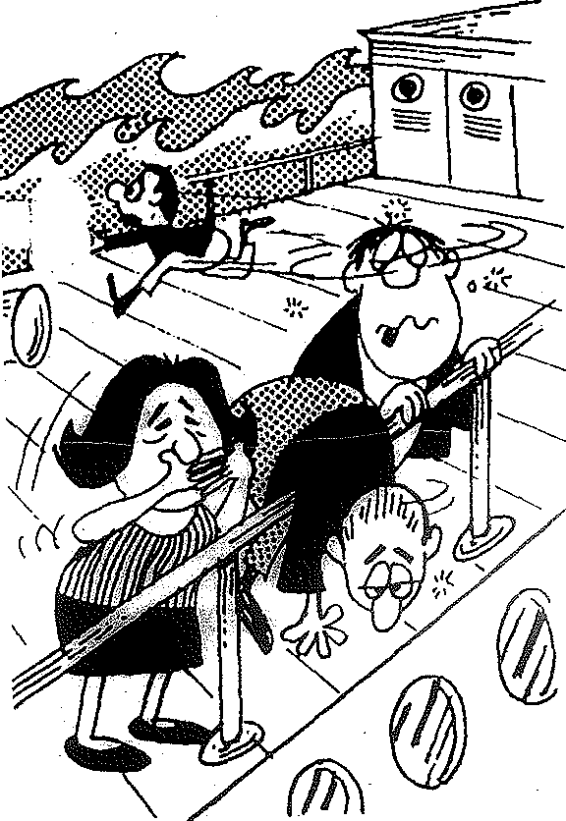
The Polonia

At last, on June 10, 1923, we were able to board a huge boat, the Polonia. Before boarding, the RIAS people took us to a bathhouse and gave us a steam treatment. Even our clothes
were steamed to protect us from lice. After the bathhouse there were physical examinations. We were searched for all kinds of illnesses--especially glaucoma of the eyes. Fortunately, we were healthy.
We traveled third class and it was not comfortable. The cabins were small and crowded. The waves were very high especially as we reached the Black Sea. One time the water broke through some parts of the boat. Luckily it happened at midnight when the passengers were asleep and the crew was able to fix the leak. One night while we were watching a movie, the film caught on fire. Everyone screamed, "fire." The safety· boars were placed in the ocean in case of an emergency. What panic as the passengers looked for their families. At last the

fire was extinguished and everyone returned to their cabins. One could hear, "Please, God, no more troubles. Enough is enough."
During the trip my mother and father were very sick. I was able to help because I was not seasick. One of my brother's girlfriends was traveling first class so when my brother got very sick, she took him in her cabin and nursed him back to health. Due to the erratic Atlantic, there were so many sick
people--and just one doctor and two nurses to take care of them. Cries for help were heard all over the boat, especially in the lower class cabins. Occasionally the whole family was able
to spend some time during the day in the first class section and catch some sunshine and breathe some pure air.
It 'Was a Very Good Year
Ca'.stle Garden

Hurray'. The Polonia landed in the United States on July 4, 1923, and the illlllligrants were received at Castle Garden. It was the last walk to reach the gates of freedom.
Inside .Castle Garden we entered a massive hall and broke into dozens of lines, each divided by metal railings. There, they put a big white chalk mark on my shoulders and took me out of the family line. Others needing further medical checking were marked "H" for heart, "K" for hernia, "Sc" for scalp, and "x" fer mental defects.
What a heartbreak now knowing where the inspector was taking you. I knew that this was a place where families were

separated because of minor medical and physical conditions. An official took me to a room on the upper floor and closed the door behind me. I waited about five hours and worried about what was happening to my family. In the middle of my thoughts, a nice g.irl came in, handed me a Russian book, and told me to read. How amazed she was to see how well I read.
She said she was sorry to cause me so much grief. She thought I was illiterate because I failed to answer questions -which were asked of me. My mind must have been on my father's physical exam. I was hoping that he would pass it.
I was overjoyed. We were on our way to being reunited with our loved ones. now can I describe the happiness at see­ ing my brothers? Can you imagine how my parents felt after seeing their sons after 10 years?
After the war and the Revolution in Russia, we were finally at the entrance to the "goldeneh medinah" (Golden Medina)--where the streets were paved with gold. All of our relatives and friends were standing and waiting at the gates of Castle Garden in New York--waiting to welcome us to the land of freedom and opportunity. What a reunion!

The Best Years of My Life

We arrived at the home of my brother, Sam, and my
sister-in-law, May, on Spaulding Avenue in Chicago. The home was so beautiful and full of love.
At last I had to start a life of my own. My first job consisted of sewing buttons on overalls. I worked in a base- ment and earned $10 a week. I took the job because I did not have to work on the Sabbath. I'll never forget the excite­ ment and happiness of receiving my first check. During the night I went to school to learn English.
The second job was working for my cousin, Ann Kaplan, and her husband, in a drygoods store. My salary was $25 a week.
My third job was in a factory--sewing dresses. I earned
$35 a week. When I applied for the job, they said they wanted someone with experience ....and I did not know very much. But I said I knew how to do the work. I sat at a table with 12 women. One of the women, Sarah, was very pleasant. When the forelady brought me a dress and asked me to fix the hem, I
really did not know how to handle it. Sarah saw the expression on my face. She gave me her v ry expensive silk dress and wrote my nan.eon it. She then took my dress. Her dresses were never examined. When I was supposed to leave for the day, the forelady and the boss were very satisfied with my work.
I continued switching dresses for six months until I became very experienced; I kept this job until I got married on March 10, 1925.

-,30-

Sam and I are Married: 1925

About September of 1923, I went with my sister-in-law, May, and her daughter, Ruth, to visit her sister, Ann, in Chicago. I opened the door to her home and saw a man sitting comfortably in a hair. He was a friend bf cousin Cohen. He looked very handsome in his brown suit. We were introduced and I quickly noticed a sparkle of joy in his eyes. We
spent an evening together and then he walked me home. We went to the movies and saw "The Hunchback of Notre Dame," and I enjoyed it very much. We continued to go steady, al­ though I told him, "Sam, I am still in love with my friend from Russia and continue to correspond with him."
But Sam is very much in love with me. He would tell me that his love was so great that it would take care of both of us, and that he hoped thatfn time I would learn to love him. His dream came true. After two and a half years of going steady, we were married on March 10, 1925. The whole mishpocha were there. We had a big orthodox wedding in a hall on Ogden Street--and seven times we marched around. All of us were very happy since our wedding was the first one in the family.
But our happiness ended the morning after the wedding. we had to rush my father to the hospital; he was suffering from
cancer. I was by his bed for six weeks. I remember his words: "We all have to die, but the thought that you are going to die is horrible."

WZB £

-31-


, t .
.

Wyandotte, Michi an

Five months after our marriage we moved to Wyandotte,
Michigan. We opened a tire store with $200 cash and $1,000
in credit. The rent for the store was $40 and we paid $40 rent for our apartment. We started a very good business. Then the
·1Depression came and we lost our business and home and moved to a small apartment. Sam took it very hard. I tried to keep up my courage and spirit, and it paid off. Our name was good.
The Goodrich Tire Company came to us with a suggestion.
They would give us all the merchandise and we could sell tires on credit. The business was flourishing since we were the first people in Wyandotte to sell on credit. A couple of years
later, five stores (Sears, Firestone, Goodyear, etc.) opened
up and started to cut prices. we were not able to compete with them and were forced to close the business. Again we lost
everythin& _except our good name. Once again we started to look for another way to make a living. Fortunately, a gas station was available and the bank gave.us the money. We started to build up a rundown station. I worked like a slave.

-32-

But, again, life is not full of roses. I lost my first born boy in 1926. I got very sick with a goiter and it was a miracle that I recovered. (Years later my happy life was once again disrupted when I had a second operation on the goiter. I was left speechless, with little hope of getting my voice back. After eight months of pain, I did regain my voice).



Miriam, Dorothy and Daniel
On October 24, 1927, our daughter, Miriam, arrived.
Eighteen months later, on April 10, 1930, Dorothy arrived. Again, life is what it is. Our son, Daniel, was born on Silturday morning, April 30, 1932.
T can still hear the do tor's voice. It sounded like music to me: "Mrs. Fogel, a kaddfshel is born to you and Sam.
r-!azel-Tov ! I-Iave a lot of naches from your son."

Strange as it sounds1
I can still remember
. ' .
Jumping and

screaming, 11That is not my son!" The nurse--by mistake--had taken a 3 1/2 pound Polish boy and brought him to my bed. I would not have known the difference if I had not seen Daniel once before.
The next Saturday we brought him home to our beautiful
brick home on McKinley Street. The yard was filled with apple and plum trees.
The Miracle: 1936
The greatest miracle in my life happened when my son, Daniel, was four years old. on Friday night, when my Shabbos candles were glittering, my son wanted to try some experiments. Ire waved his hand the way the candles waved and his new flannel pajamas caught on fire. Fortunately, I was on the telephone nearby. Just imagine my fright seeing my son in flames. I
do not know where my strength came from, but I grabbed him in my arms and extinguished the flames. We rushed him to the hospital. Unfortunately, years ago they did not have the medi­
cation or the knowledge tnat they have today. I was with oantel

in the hospital for three weeks. He was suffering so much that my heart was aching. I couldn't help him, nor relieve the pain. It looked like he was getting better. I was so ex­ hausted that my family wanted me to come home for at least.one night. so we had a private nurse that night. She did not watch him carefully, however, and Daniel scratched himself
and caused an infection. His whole side was red and he could hardly eat or drink. He was fed intraveneously. One week later, the doctor examined him and gave him little hope for survival.
While I was standing outside of his room, it must have
been like waiting for Elijah. God sent us an Elijah--Dr. Cohen. He asked, "Mrs. Fogel, why are you crying?" I said, "Please, doctor, help me save my son." He said that he could not come on another doctor's case, but that he would make an exception and see what he could do. He ordered a bathtub full of ice and placed Daniel in it. He then placed Daniel in a hot bathtub. The doctor asked my husband and my brother, Morris, to give him six pints of blood. Daniel started to gain his strength, and after three weeks, we took him home.
He had open sores on his skin and I had to watch him carefully to prevent him from catching a cold or any other sickness.
Imagine our feelings when Miriam and Dorothy came home with chicken pox. I could not get any help in the house on account of Daniel's condition. After three months, he felt better.
An operation was then needed. Skin grafting was -needed. It left some scars,·but who cares!
That summer we rented a cottage in Woodhall Lake and Daniel regained his strength.

he hest years of my life? Personally, I think they were when my children were young. I used to get up at six o'clock in the morning and get hreakfast ready. I would hear their voices, loud and sweet: ''Mom, how's the cereal and cocoa this

morni• ng.? 11
You had a purpose in life--seeing them grow up so

beautifully.
I spent every spare minute with my children trying to teach them to be good persons. My goal was to encourage them, not discourage them. If they made a mistake, I taught them not to repeat the same mistake a second time.
I never had an open account when the children were young.
I taught them to spend the cash, if they had it. If not, I told them to wait till they had the cash. I still believe that even in my old age.
The years went by swiftly and soon we were celebrating Daniel's Bar Mitzvah--a happy and beautiful occasion. Then came Miriam's college graduation, Dorothy's graduation a year later, and Daniel's graduation, five years later. My pen can­
not describe all the happiness we had sharing these memorable occasions.

-.36-

The Grandchildren

Life is a parade of hapoeninos. F.verv day, every moment, somethino is hannenino.
Now rnv children beqin to have their own families and I become the nroud oranclmother a" Allen Howard, R.onna Beth, Barry, Larry, Caren Shelly, Kenneth David, and Steven tharles.
I can still the remember June 19, the day Caren was born.
I visited Eleanor and Daniel in Cincinnati while Daniel was still in Rabbinical colleqe. About 3 o'clock Eleanor started to have labor pains. Daniel and I took her to the hospital and at 6 o'clock, the nurse announced that a dauqhter was born. Mother was fine. The next day I went to see Eleanor and my qranddauqhter.
Eleanor looked beautiful and happy; Daniel was the happiest and proudest father. We celebrated--my family, Eleanor's family, and the conqreoation. When Daniel started the blessing to Caren, there were tears in everyone's eyes.

I was the hapniest grandmother. in the world.
I wish Caren all the happiness

More simchas: I can still hear mv son's voice on the telephone sayinq, ''Mom, we have a son--a beautiful baby, 7 pounds. Eleanor and our son are feelinq fine, so come soon; we need you very much." I callecl for reservations ancl in one hour I was on the way to be with-mv r1ear ones. There are not cnouqh words to r1escribe my happiness at the arrivctl of mv

-37-

new-born grandson, Kenneth. Kenneth was born on the first clay of Rosh Hashannah.
My joy was great. Eleanor looked so well and the baby wc1s so cute. The hris was held in a special room in the hospital. Rabbi Rubin was the Godfather and I was the God­ mother. l'le had refreshments and went to the apartment where Caren was being taken care of by the babysitter.

Ken's Bar Mitzvah

It seems like yesterday that we were celebrating Ken's Bar Mitzvah. On the Friday before the Bar Mitzvah, we pre­ pared a Shabbat dinner. The table was set with the best dishes and silver. Kenneth looked so handsome; Caren looked just beautiful. Eleanor and Daniel were beaming with happi­ ness. For me it was the greatest time in my life.
After dinner we went to services, where hundreds of friends came to help us celebrate. The services were spiritual and. the sermon was inspiring. After services the Sisterhood prepared the most delicious refreshments.
Saturday morning, at 8 o'clock, we all got ready for Temple services. The weather was so beautiful and warm. Just like they say, "Rabbi's luck'"--and that was double luck because it was the Rabbi's and Rebitzin's son's Bar Mitzvah. God, what a magnificent sight to see a gathering like this. All my children and grandchildren looked great. I was wear­ ing a long dress and looked pretty •.•if I do say so myself.
When the services started, you could hear a pin drop.
There was complete silence. Tears of happiness were streaming down from my eyes. I felt as if my heart had stopped beating.
My son, Kenny and Caren, were reading from the Torah.
There was a shine on their faces. Kenny performed the whole service and was really great. When my son stai::ted to bless his son, there ·was a wave of spiritual silence.

After the services we went to the Temple hall, which was beautifully decorated with yellow chrysanthemums. The
food was delicious and an Israeli band entertained us. Every­ body had a wonderful time, and this was one of the happiest days of my life.
After the affair everyone w nt back to Daniel and Eleanor's home. On Sunday most of the relatives left for home.

So my baby·grandson's Bar Mitzvah was over. to look forward to my grandchildrens' weddings.
Now I have I hope that

I shall be able to celebrate many happy occasions, Please, God, give me only good things in life.

Ronna and Larry

Today we went to visit Ronna and Larry in Ann Arbor.
How stranqe to see Ann Arbor again after 20 years. Dorothy
and Daniel went to college there. Now I visit my qrandchildren and enjoy it very much. l e also visited the Rattrays and spent a couple of hours talkinq about the olden days.
Dorothy and I went shopping and met Marilyn Gordon, for lunch. On the way back we visited with Sylvia and Leonard. So I think I did a day's work.
Whenever I go to Dorothy's, I always try to see Ed and Jo Simon. Ed is one of the finest men I know. He is a friend in good times as well as bad. For instance, when my husband was stricken with a heart attack and I was forced to sell the gas station, he helped for months. I don't know what I would have done without friends like Ed and Joe. God should help them, their wonderful family, and give them all the happiness
in the world. I have no words to express my thanks and appre­ ciation for their friendship.

Naches and Tsores

Shepen naches is attending our daughter, Miriam's marriage to Leonard.
Shepen naches is also attending Dorothy's marriage to
Martin.
One hot August day, my husband had a terrible heart attack. The doctors gave up hope, but he survived. We had to sell our station and move to Florida. It is hard for me to believe that this episode ever happened.
When we moved to Florida, we bought a lovely home, furnished it nicely, and the lovely children and grandchildren visited us. We had a beautiful housewarming and invited all of our friends and relatives. My daughter, Miriam, Allen and Barry were there with us to enjoy the happy occasion.
Then on July 15, 1957, we went to Detroit for our son's wedding. We were getting ready to go home to Florida, and Sam had a heart attack and passed away. I was in shock for a long time--about seven months. I could not stay in my
Florida home for long and sold it. I bought a home in Detroit. Then I went to Israel for six months and had a nice time.
I came back for my son's ordination. This was the happiest occasion that a mother could wish for. Miriam, Dorothy, and
my brother, Max, and Sophie shared my happiness.
Then I went to California for a visit to my brothers and bouqht an apartment. I lived there eight months, but felt it

was too far from my children. back to my son in Roslyn.

I sold my apartment ann came

Aqain I moved to Florida, this time buyinq a condominium for $10,000. I enjoy it very much.


( MAZEL
'·

Today is Dorothy and Martin1s Silver·anniversary. I wish them Mazel-Tov and all the happiness in the world.
Dorothy, Martin, and the children called" It was my
greatest happiness to talk to them. God, what memories go
through my mind.
How strange this may sound. It is unbelievable that
25 years could pass so quickly. It seems like a dream, but

it is a reality.

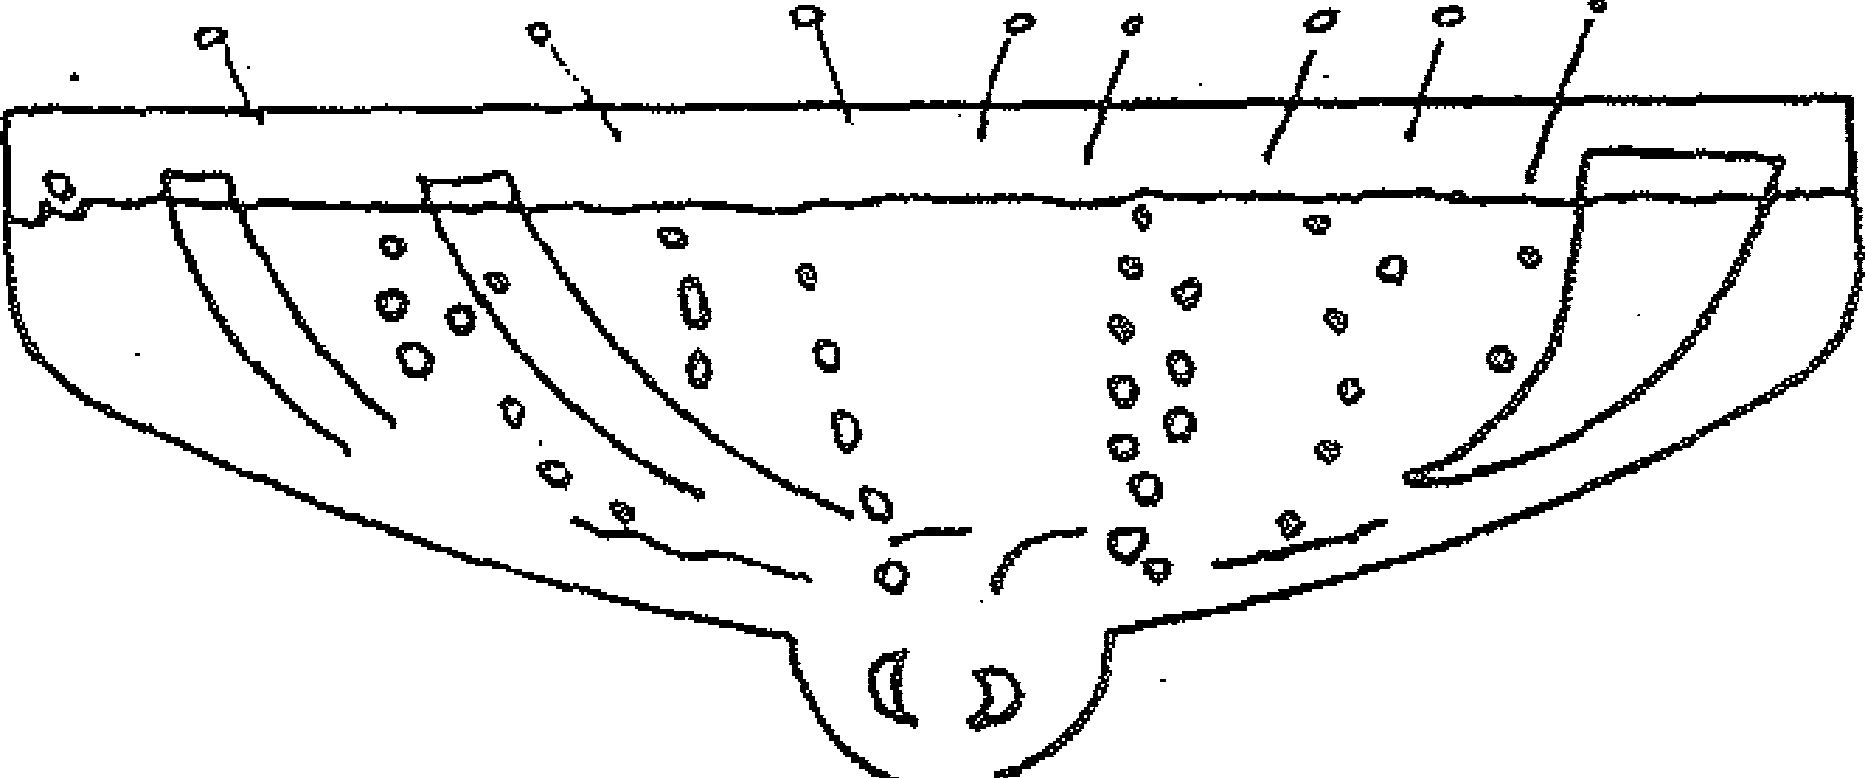

4
\, ti VV
/
\
•vl=lis v


Ain Karem
MEETING
I

The first couple of years in Star Lakes, Florida, were most enjoyable and productive. Eleven years ago, in 1966, I organized a Hadassah group, Ain Karem. It was a very hard job because every one of the ladies was against it. They said
that they had had enough of the groups up north and that they
had come to Star Lakes, North Miami Beach, to relax and enjoy themselves.
But I am what I am, and I continued to bake my hazen blozen and strudel and invite the girls for coffee and dessert,
Finally, the ladies agreed to start a new chapter of Hadassah.
I made lunches for everyone who was interested in joining.
I used to bake and make all kinds ·• of egg and tuna salads. I solicited nice presents from Burdines, Richards, and the rest of the stores. At the end· of two years our chapter had 100 members. The group grew to 250 memqers.

I remember my first speech at Ain Karem. My knees were trembling, but I made it.
Dear Friends and Members:
At last my dream comes• true. We have a new-born baby--Ain Karem, and this is one of the happiest mo­ ments of my life. Needless to say, I am scared. But, with prayer and courage, we will meet the challenge.
We have made a wonderful beginning, but we still h ve a long way to go.
In the near future we will be proud of our group. We pledge to help in honoring the 20th anniversary of Israel. We pledge to help heal the sick and wipe away the tears of the children with music and song. The more members, we have, the more we can accomplish.
We ask Thy blessings, 0 God. Give us the fore­ sight to plan with care and judgment the activities of Ain Karem. I thank you, all-my dear friends, with all my heart.
To you, the president and the officers, come my wishes for your good health and happiness.

Syosset, my second home February 15, 1975
I spent this winter in Syosset, Long Island (New York), where my son is the Rabbi at North Shore Synaqoque. Syosset has been my home for seven years.
The Synaqogue is simply beautiful--surrounded by lots of trees and shrubs. It has about 450 members and the people
arc wonderful and intelligent. They admire Daniel and Eleanor very much and show their love for them.
I love Syosset very much and have acquired a lot of wonder- ful friends. I belong to Hadassah, ORT, Temple Sisterhood, a Yiddish group, and Saturday minyon, where we spend five hours reading and discussing different topics.
I especially enjoy Friday night. I have so much naches when I see my son on the pulpit carrying the Torah in his arms. His sermons are so inspiring to me and to the rest of the con­ gregation. After services we gather for refreshments and dis­ cussions. Everybody seems to like me a lot. They think of
me as a great mother of a great Rabbi.
I remember with joy the second seder we had at the Temple.
Everybody had to bring their own food and we shared a table with the Stern family.
The first seder night we were invited to the home of Rabbi Rosen and Esther. We sat with their daughter and two sons. lie were surrounded by fifteen guests. The table was
set so beautifully. We started the seder services at n o'clock
and finished at 11 o'clock.

These past months were a combination of joy and a lot of trouble with one of my teeth. The dentist in Florida was a butcher and it took almost three months to clear up my dental problems. Luckily, I had a qood dentist here. If the infection had not been corrected, it would have poisoned my system.
I'm amazed at how fast the five months have gone.. It was a cold winter, but I felt good. Maybe it's because I
had such a wonderful time surrounded by Daniel, Eleanor, Caren, and Kenny. My good friends brought me so much warmth and love that it made up for all the snow and rain.
I'm getting ready to go home soon after Pesach. But, believe it or not, I don't feel like going home--even though the weather in Florida is much nicer. But even the sun does not give me as much warmth as I find here in Syosset.


JULY 4, 1975

It is Friday, the Fourth of July, 1975. It is supposed to be my birthday, and my children are making a big deal. I got up at 9 o'clock in the morning and at 10:30 had breakfast with my best friend, Ida. I had a waffle and coffee and re­ turned home to swim in my lake. I talked for awhile with Ida. Then it start d to rain.
I came into my house to wait for the telephone to ring, At five o'clock my sweet daughter, Dorothy, Larry, and Steven called. It was so wonderful to hear their voices. Ronna was in camp. At 10 p.m. Daniel, Eleanor and Kenny called. Caren also was in camp. rrHappy birthday, Mom and Bubbe. 11 Then Miriam called. I was really happy to hear that she moved to a nice apartment with a swimming pool. Let's hope next year we'll celebrate again and that we're all in good health.
I was watching television and the telephone rang. I ran to answer it. "Hi, Bubbe.n I•-was happy to hear Allen's voice. We talked quite awhile about different subjects. He told me he was going to continue hi-s college education. I was very

proud and happy because I always believed in his ability. Thanks God that my hopes come true--my blessings and best wishes for Allen's future.
How strange to realize that 52 years have passed since
we came to the United States from Russia. God, how many memories and episodes start to come to mind. First I recall seeing
the Statue of Liberty. Then I remember myself so young and beautiful--with a full head of curls. I'm dressed in a light blue suit, walking with so much enthusiasm and hope--and a future full of dreams. God, how fast life seems to have passed.
I look at myself af er 52 years. My head is full of gray hair, my beautiful face wrinkled, and my legs full of varicose veins.
I try my best to survive. I think, "Where do I go from here?" In the old days I had so many difficult problems and I was able to solve them--right or wrong. But not it is more difficult to decide. Shall I sell my home or not? Where do I go? Shall I live with my children? Rent an apartment?
Stay where I am?
As we travel on the road of life, we face so many obstacles. Some of them are really difficult to battle with... not knowing which road to take. Left or right? At each turn

there are some good, some not so good choices. through life just taking chances.
So, we swim

Sunday, March 4, 1979

I had a miserable day worrying about Israel. 1•Ihat will happen? There are so many humans ready to destroy Israel, includinn Prcsidc11t Carterr his brother, nilly, and Sarlat.
God, wl1y die} loses }Jrinn us out fro the wilderness into a , orse wilderness?
Dut as we approach Purim, in the year 5739 (1979), my hopes and prayers are to qet rid of all our enemies. What happened in Mordehai and Esther's time should happen in

our time....in Israel, and all over the world. of ha piness and joy, please, rioCT.
A little bit

Note

On March 26, 1979, a peace treaty was signed with Israel.
Ecynt became the first Arab nation to recoanize the exist­ ence of Israel. The treaty capped 16 months of difficult neqotiations. It was signed bv President Anwar al-Sadat and Israel's Prime Minister, enachern Aeqin in Washincrton, D.C.
The formal clocuments 1•1ere e:-:channed on Anril 25 at Umm Khisheib in the Sinai Israel lJcaan its Sinai withdrawal or1 May 25,
t rninq over the town of El hrish to Ecyot.

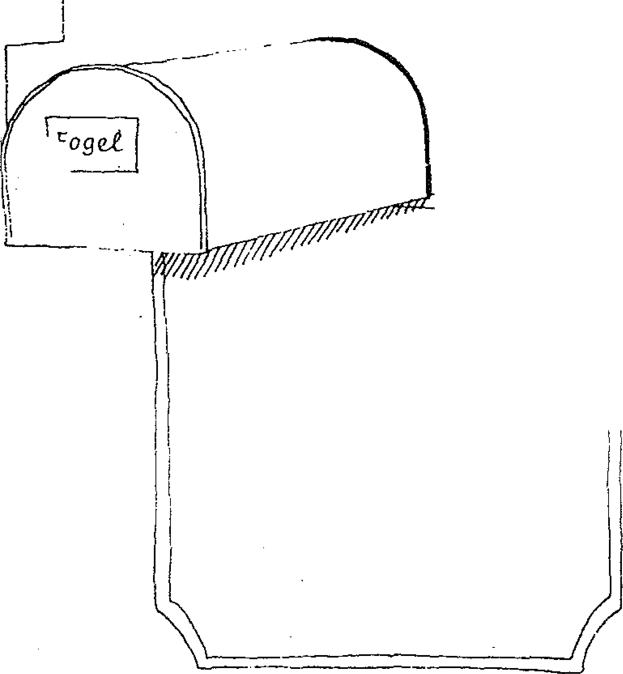
The Magic Box

The "Magic Box" is the mailbox. Does anyone realize how important the mailbox is in my life? I spend about half of my life running to the mailbox. Everyday I wait and hope that there is a letter.....or maybe two or three. When there is no mail in the "Magic Box, 11 ·how disappointed and miserable I feel for the rest ofthe day.
j
I just wish my children and grandchildren would just know.
If they did, they surely would find five minutes more often
to write. But they have their life also--with so many different problems and responsibilities, God bless them all.

Graduation

To all my dearest grandchildren:
I wish to congratulate you on your graduation from high school. The diploma is just .the beginning of your career; it is the beginning of an educatiqn.
My dearest, as the years go by, you will understand more and more the beauty of education--the great wisdom. Once you acquire it, you can never lose it. Education is the most pre­ cious gift one can give oneself. No one can take it away from you. Man may acquire richness--and lose it--but man will never lose the wealth of knowledge.
Thank about it'. You are building the foundation of your life's future, like an architect, who makes the blueprints for a building. He has to make the foundation good and strong,
to hold up the building for years and years. Now, at your age, you are laying the foundation of your future. Build it good and strong.
Love,
Grandma

-53-

My Lake.
I don't remember if I ever described my palace or cas.tle.
My lake (Star Lakes, Florida) is so beautiful. It's shining and peaceful. Even Chagall would not be able to paint a

picture like that. and peaceful?
Why can't a person's life be as beautiful

But, like my mother used to say: "Gay freg a kashe bye dem Rebe Neshlom.• Translated, it means "Go ask God a question."
However strange it may sound to my children, the lake is a part of my life. I could sit for hours at a time watching
the waves. The fish are swimming around and around enjoying
life. Each fish has its own identify, and must struggle for


survival, This struggle goes on day and night.
: \:';.
·!
. \\Hi
_ .• ,t;•.• '•!f:r·\
. !


Mother's
Day
1978

Tcday is Mother's Day. This is a beautiful day--one
that mothers really deserve. What a beautiful word--"mother." As a mother I am blessed with children and grandchildren,
and I pray for their long life, good health, and happiness.
For all the labor, is there another profession that pays netter wages or benefits? I say, "No." From my personal life I made the best investment in the world by having my precious children. Their love makes my life so beautiful and happy.
First, sweet Ronna called. "Happy Bubbe's Day." Oh, to
hear her voice and know that she feels good and enjoys her work. Ronna serves and helps needy patients. God bless her with a lot of happiness.
Next, Miriam called. "Happy Mother's Day, Mom. I am coming to see you on the 29th of June." I am very pleased to hear the qood news and look forward to seeing her soon. Maybe narry 1 ill be able to come along. I hope so.
Three o'clock in the afternoon the telephone rings and I
answer it. "Hi, Mom. nappy Mother's Day," I hear Eleanor and

-55-

Daniel's voice say. It sounds like the sweetest music. Caren is in college, but she sent me a beautiful letter expressing her love to me. She says she appreciates my in­ spiration and wisdom. Kenny was working and was not able to say "Hello," but I know his love 'for me is great. I felt it in my bones. God bless you all.
Dorothy called to wish me the happiest Mother's and Bubbe's Day. Ronna is in Ann Arbor, Larry is in Boston, and Stev n, the doctor, is in Lansing visiting his girlfriend.
Last, but not least, Allen called to say "Hello, I love you. very much." We talked for a long time and he promised to make me proud and happy....to change his life
style for the better•....and even to go to Israel to make his home. I hope so.
The whole day was beautiful.

Let's Pretend

Time is nearing for.me to leave for my journey to visit my family. I look upon it with mixed emotions. As the years are passing by, it is getting harder and harder to decide which direction to take.
I live more in the world of "Let's Pretend"--a game my grandson, Allen, used to play when he was a baby of thre years old. No wonder they say that the older you get, the more you resemble a young child who dreams and pretends.
Sometimes I don't recognize myself. I used to make up my mind in minutes--now it takes me years. And, sometimes, I still can't make up my mind which road to take. I always wonder what the future will bring.
Why is life so mysterious and sometimes so discouragi1J_g.
I never thought I'd be afraid to grow old. I now see what age did to Max. It scares me a lot.
People wonder why I rent my home in the winter and qo
up north. The real truth is because I need the money. I save up to $10,000 and it lasts me three or four years. Then I do not have to come to my dear children for help. I always hope to be able to be indenennent, and pray I continue to have
good health.

Television--The ''Maqic Box"


How strange it is. How important a tele­ vision becomes in your lazy life. It becomes your best friend. It keeps me from qoinq nuts. ny watchinq all of the nroqrams you seem to qet over some of the loneliness, You concentrate on what is hanpeninq in that 0roqram, Sometimes there is a lot of reality and truth in the pro- qra.m.
Recently I watched a television show which dealt with children's responsibility to aqed parents, especially when one of the parents is left alone or in poor health. The truth is that parents can take care of 10 children, but 10 children cannot take care of one parent.
But the traqedy is that parents become children to their children. At the aqe of 70 or 80--or older--parents become a burdeno The children must carry the responsibility for their own family as well as their parents.
Personally, I hope and pray to God that I do not become a burden to my chilnren. I will try with my last strenqth not to be a cause of

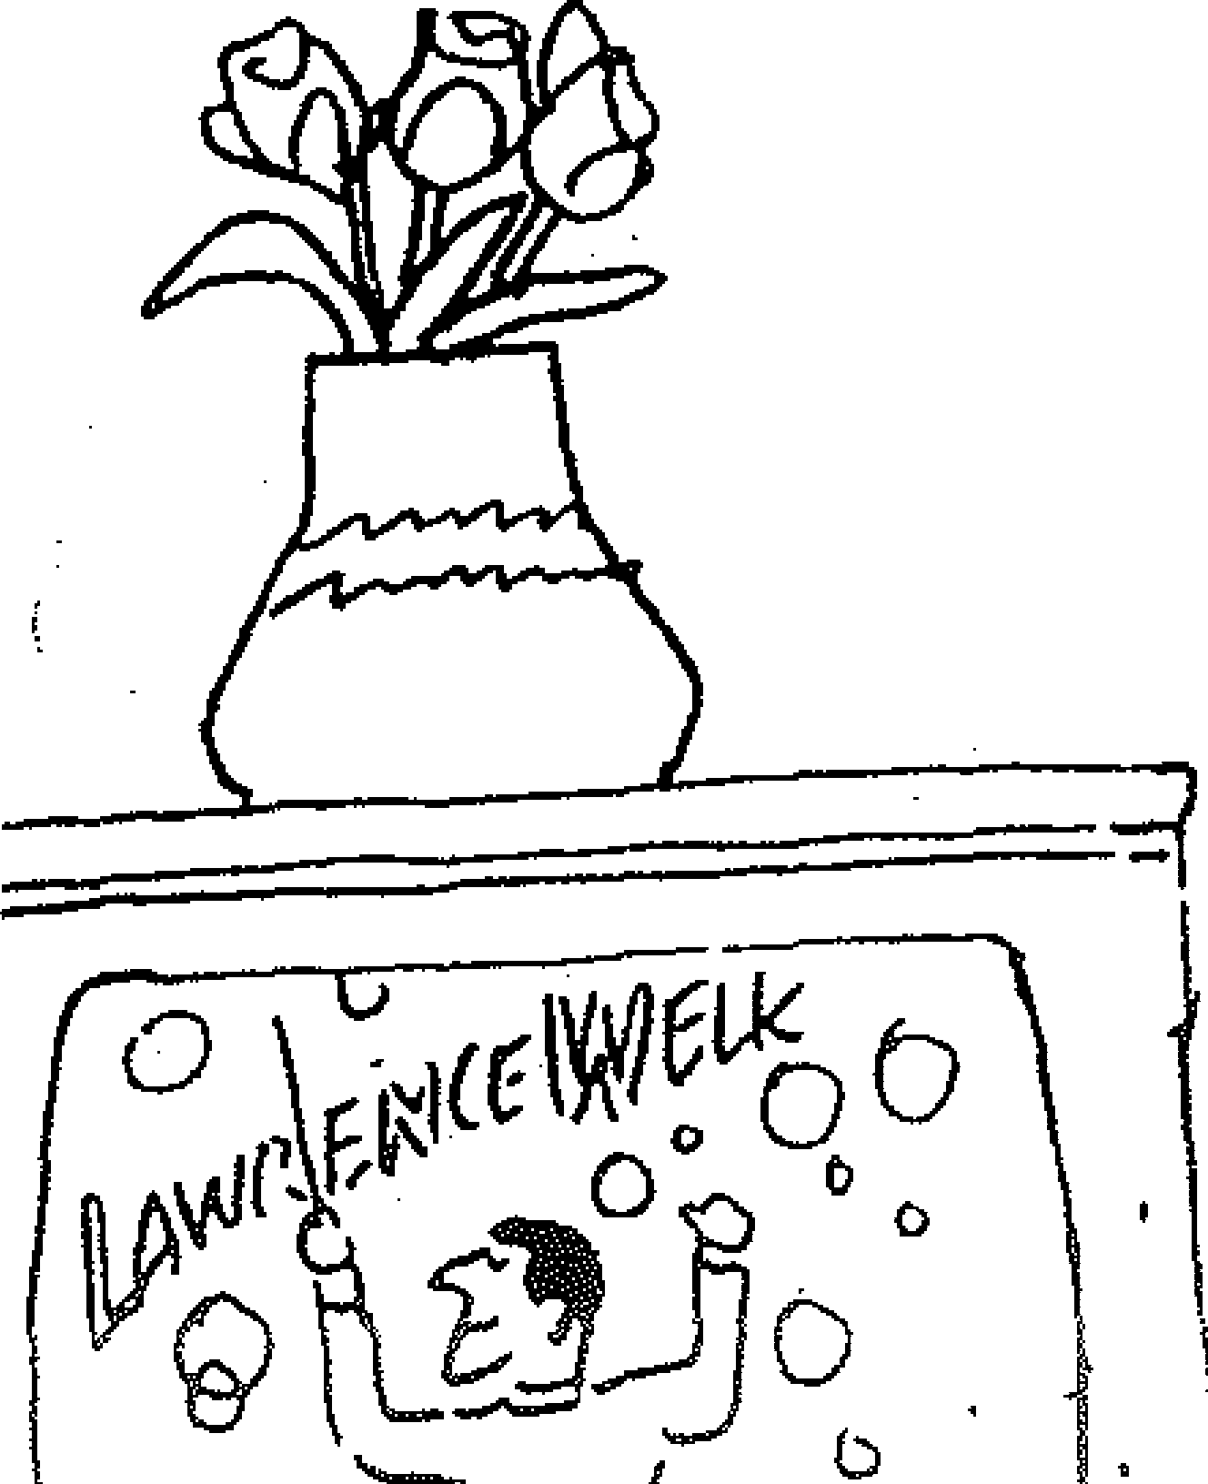



unhappiness to my family.
DO
b

00
J
much.
It would hurt me so

!1y Mother Lives in Miami Beach

I am sittinq on my porch, knittinq an afqhan for Larry's hioh school gra,luation. I hope he will use it in CfOOct health.
/\ television oroqram appeared: "My Mother Lives in Miami Reach." The Picture was very depressinq. Tlunctreds of thousands of lonely, elderly mothers are shown sittinq in their rooms, dreaminq of the ctavs when they were with th ir loved ones.
I think--rcqardless of the hard work and responsibilities and worries--those early days were the happiest days of their lives. Now their lives are empty. Some are even forgotten
by their children. They were sent away to the "land of
sunshine."
Yes, thank God, there is a Mother's Day once a year.
They send a card.

Love is Better than Hate

1•1e humans keep on complaininq--not satisfied with
the way we live.
Envy, jealousy and hate is the daily diet of the majority of the human race. Why don't people realize that love is better than hate, that joy and hapoiness are the niost importnnt things in life?
Years pass by like a flash of liqhteninq and all is just like a dream. \'/hen we are young, we don't realize what life is all about. It is when we grow ol<ler that it becomes a reality.

The Golden Years--The Broken Dreams
One day is just as another day. Nights are worse than days, except that you sleep and dream of the years that have passed.
How I wish I coul<l go back to my younger years and younq dreams. But I have to forget about that--now that I am older.
Dut who am I to complain about my life. In the game of Life, I think I did a pretty darn qood job, with the help of my dear friend, Sam. So, all in all, thanks to Goel, we

raised two beautiful daughters and a handsome son. course, we have seven great grandchildren.
And, of

I'm the happiest mother and Rube, Lillian Fogel, in
the whole world, including Israel and the United States. God bless us all with happiness and joy.

FINL/INO ,,

111!\JMM
I
I

isMUfMM

Vrilmiy Voloc/,ot

/ Vilnius
I 0
!

Yo'11lni,III,₀
I
p,oliohotl'
/olom.Jol1l • '°
Kozn11

.,.o.1nu1m,

111 t·\11 I' "llt:JII
Uly!lnoysk6 •
Mololoi,
luly,olh
l<Vyhysiio
I

\1p,1ii •hnibov

₀Voronoz!1
Kll1nQllr Smon f
Cli1poyo,1l'
I

)
)
(

Yovpalollya• Cl UM LI\
.
.
'i
i
Simlotopo/0
& fcodosiyf Samto ot •fofla
.
01noa11nor1toyo iiU101011l
•Slnranil-na-Kulioni Kropo1lin
Astrokhnn
0

l.,."·· --..
Novoromr,t. Krnsnouar llm,avi,
- -o-Sl1,1v-ru1ml

EUROPEAN UUSSIA
(U.S.S.R.) Political Map
LJ
Moyl:o; L0abln1l • l,ovinno1r1yul
Cleo1l ai., .,M11,01;dnn• Vo,lr
YClltntUh,. "l'y . l

l:i1lovod1t• iUgon

_ (fy Mt1llonol Cof>llul
- C Olhor Clly or Tow11
l!o1n1hlic
lloundory

Sutlrum/
llolclul₀



Gruznn. /;l,01:ifarl
_.. •ord1l1onilid1c . •

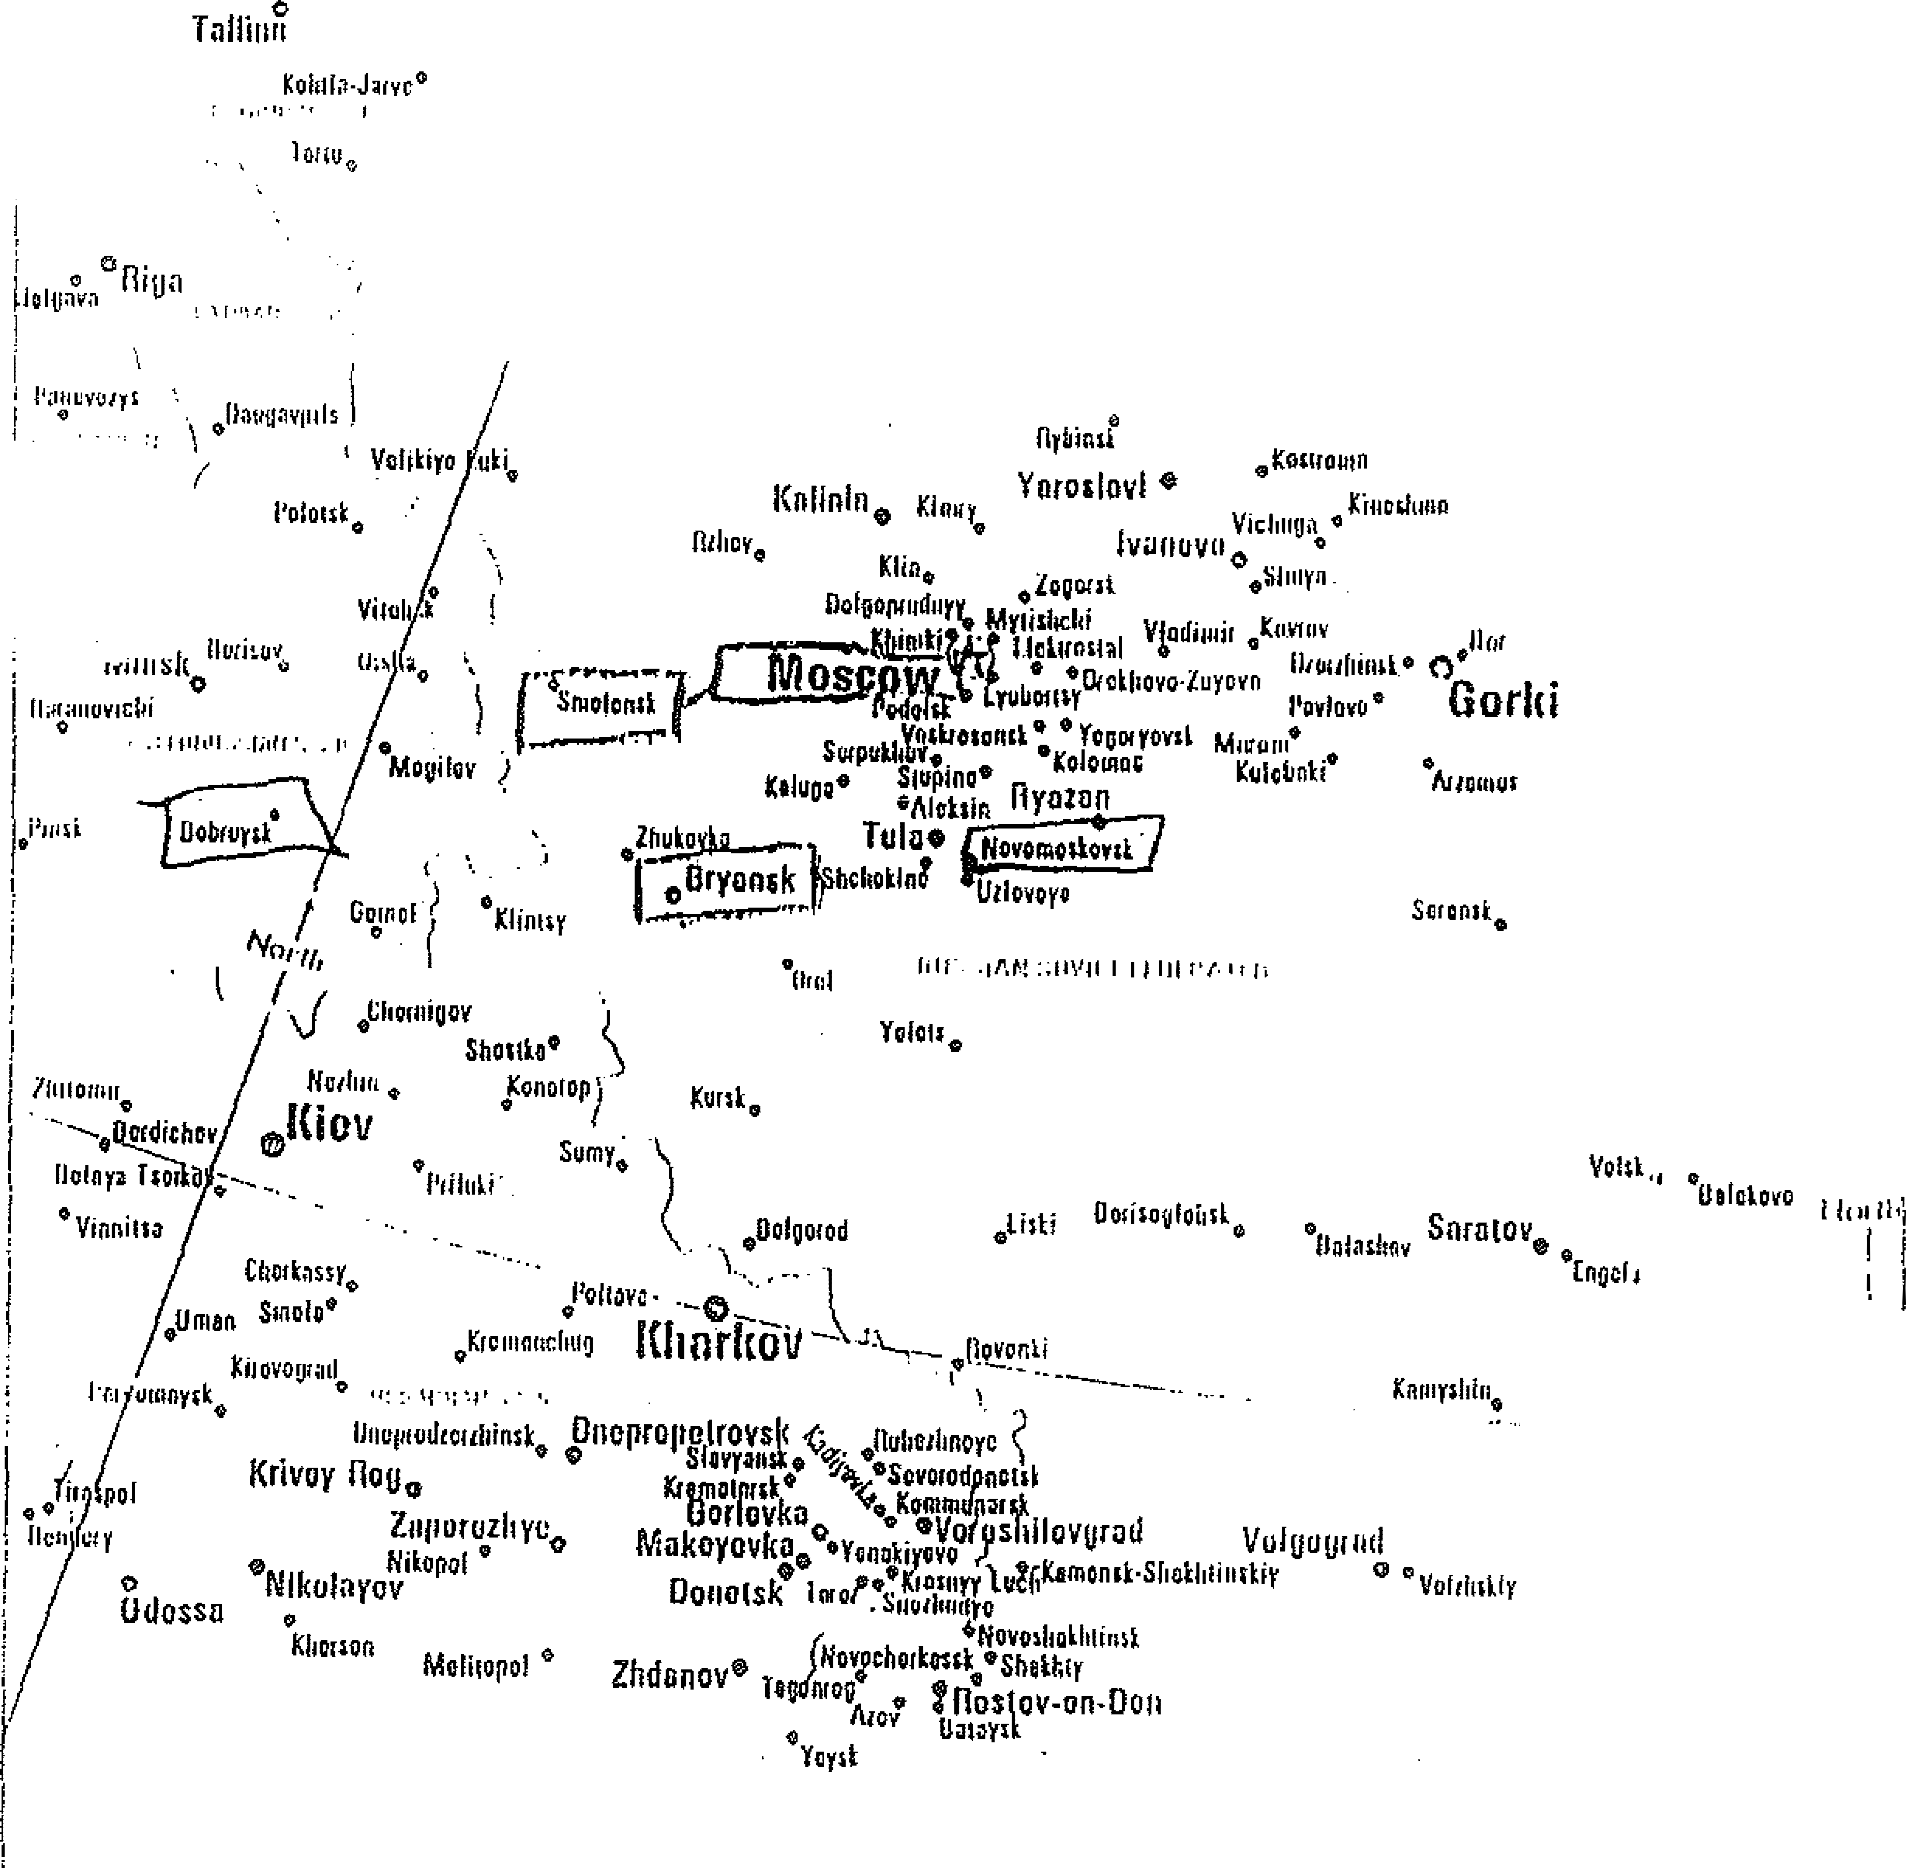

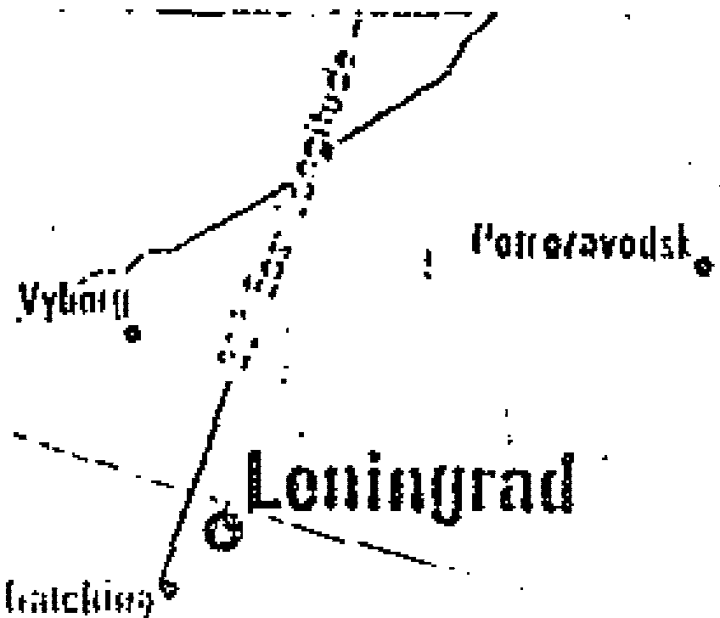



.dt L..
·-^{e}..⁻n^{s}•^{m}.-¹
f Miier I· If I
0 KU01nolon WO
200
I ( I
JOO 400
( Kul;hi
Poll• • 1,wi,1.11.,,
- I·---·· .

. ·. h
\, ,
(
Malhod,lolu

1-....,...., 1•, ,t,IH,1t
tYUU -1• IHUUU M••1•



DISCOVERY
Grandma Remembers

By Marjorie Wolfe
When vice presidential candidate Geraldine Ferraro and Gov. Mario Cuomo spoke of their immigrant roots, it struck B_responsive chord in millions of Americans. The Great Hall of Ellis Islantj ..:;ill begin a $128 million renovation From its opening in 1892 to its iqsing in 1954, Ellis Island processed more than 17 million newcomers. bim Fogel was one of them. Lillian,. 84-yelll'-old mother of Rabbi Daniel Fogel, of Syosset, New York
landed at Castle Garden on July 4, 1923. Her self-published book, "My Journey to a:Golden Land" is told in a series of heartwarming anecdotes and
Observations. It covers her life from her"Klener" (small) shtetl in Samotevich, Russia. to the present; and is a vivid portrait of one grandmother's desire to
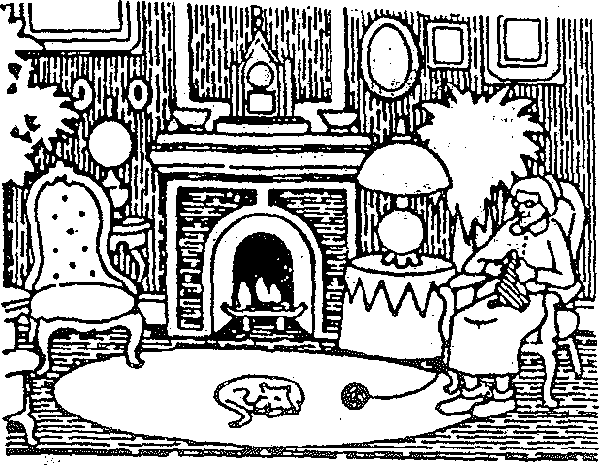

Reprinted from "Syossel Advance" 9/21/84

ro At the end of 1921, the emigration restrictions to the United St.ates were lifted and my brothers started to send letters and affidavits for us to come to the St.ates. At last my rn"G.ther-could s e her beloved children
- It looks as if I am now beco_piing orii of}ilie wande.ri1w Jews--running all over the country getting permission to lea:1.'-2. The fir-st.s_f.ep in p_reparing to leave Russia was to g t a birth certificate. L·-i-oui$hJetl \1(;:-nev i- had' ything
like_ a registration We had a Je'wis -magistrater-, 6was Ca.ll;d_ ,-"- - sta" Mmshe Bar made out the certificat inol'der to get t_he visas. Another one or'
the requirements was for my parents to. have eye elia.hiinB.tions. We tr Y Ied·

share here family "roots" with her loved ones.
by horse and buggy for three days. · ._-_ ·:
,- ',-

Excerpts from the boo.ks a.re shown below:
- A great writer I am not I started to write for my grandchildren Children
anJ grandchildren are aru::ious to know their heritage My advice, especially for grandmothers, is to start to write for your children It will give them the best gift of all
- I was born in a clayn (little) shtetl in Samotevich, Russia, Samotevich had about 500 families.
- _Ori:r own family consisted of six brothers and two sisters. I was the third
born child, with two brothers born before me. Parents were not the happiest when.a.girl was born because it was harder; you had to start ass·oonas possible
:o-save-for her dowry. But when a boy was born. there was rejoicing.
o A typi_cal dOwry was about 300 rubles. With tha:t sum of money one was
:1.ble to open a little store in the main business district
ii Samotevich was a verypretty village. The houseswere made from logs and 1ad straw roofs. We had one synagogue--orthodox. My father was the main hazen". Our shtetl had a bathhouse. The men used iton Friday, the women, n Wednesday. The price for getting into the bathhouse was three kcipe.ks for dults and. one kopek for Children
1 Winter in Ru.Ssia Usually began around the first of November and was so evere. The snow -stayed for 6. months and some of it was never removed uring the duration. of the winter.
The « chedar" was held in our home--and in other homes. Children from tree to fifteen were given religious training- J:iy a-Rebe.
=·.In··addition to raising nine Children, fily mother, Zipa Chafkin, worked
fteen hours a day to help my father provide for the family. The business tcluded leasing seven acres of land from rich landowners and cultivating and
!anting all "kinds of vegetables. MY family would then sell the vegetables to le peasants and to the people from the shtetl
In1914, when the war brOke out. life changed drastically. My oldest two
·Others, Max and Sam, had left for the United States to escape the Czarist ilitary service. We stopJ)ed getting mail from them. Murders were being 1mmitt.ed every day--all ouir Russia--and in our shtetL..gangs of bandits
!re eVerywhere, especially in the villages. People were moving to safer

- In the summer of 1923 we·Started t;o._prepafe for the vOyage to-the u.·.S..We sOld our house for350 rubles. We also sold sofee of ourfum.i"ture-"and gave the
. rest of it away. The potatoes and the flour were given to some of ol.lr
·relatives. On our trip toMoscow we carried the chicken fat in gallcinjugs. We
baked 100 pounds at bread, sllcect rt, and carried it in sacks.
:;e We arrived in Riga and a committee of kind people from IDAS (Hebrew Immigration Aid Society) took us to one of their hotels.
- We paid $200 for the visas and made the journey to Luboba The RIAS people again met us at the station Imagine our dismay to find out from the
U.S. Embassy that the Russian emigration quot.a was filled and would be closed until_ July 4, 1923. We would be stranded for six months. Our money was gone and we had to ask my brothers for help.
e At last, on June 19, 1923, we were able to board a huge boat, the Polonia Before boarding, the HIAS people took us to a bathhouse and gave us a steam treatment Even our clothes were steamed to-protect us from lice. We traveled third class and it was not comfortable. The cabins were-small and crowded
- Hurray! The Polonia landed in the U.S. on July 4, 1923, and the immigrants were received at Castle Garden It was the last walk to reach the gates of freedom. Inside Castle Garden we entered a massive hall and broke into dozens of lines, each divided by metal railings. There they puta:hig white chalk mark on myshoulders and took me outofthe family line. Others needing further medical checking were marked "H" for heart, "K'', hernia, 1'SC" for scalp, and"x" for mental defects. What a heartbreak not knowing where the·· inspector was taking yott I knew that this was a place whete families were separated because of minor medical and physical conditions.: An official took me to a room on the upper floor and closed the door behind me. I wa·itedab'out ·
five hours and worried about what was happening to my family. A "hibe_ girl
came in, handed me a Russian book, and told me to read How a zed ihe was to see how well I read She said she thought I was illiterate because'i f iled to answer questions asked of me. My mind must have been on my father's physical exam; I was hoping that he would pass it ; _ .. _ . . ,·
- I was overjoyed We were on our way to being reunited·with out_loved aties. How can !_describe the happiness at seeing my brothers.? Can'y U imli.gine

mmuniti s. I was twenty years old and considered one of the beautiful girls
how·my parents felt after not seeing their..sons for'l-0 Ye rs? :··
.-;-

the shtetl.
When the monstrous Revolution began in 1917, they took away _the little Bt my parents possessed It was called "sp_eculating." Anyone _caught with
? -sniallest amount of goods of any kind would be" sent to a labor camp. During the winter of 1920, I was fortunate to get a teachingjoh My salary 8 not paid in Dloney. Once a·month I re_ceived 40 pounds of flour, one pOund rq8ene and enough material for a coat l made a long blue coat...and the
ole world was mine. The coat lasted until Icame-to the U.S. Ireceived a pair
shoes annuaUy. ·
- After the war and the Revolution in Russia, we were fini:illy at t:hE{ ntriin.ce to the "goldeneh·medinah" (Golden Mediha)--where _tJi_e streeh\ •ek.,paved with gold All of our relatives and friends were standirig"-08. d 8.ii:.i.ng.a_t the
ga_tes of Castle Garden---waiting to welcome u.S to the land of fi_eeO.oi:h and.-­
opportunity. What a reunion! ·- ·

.ABOUT THE AUTHOR
Marjor_ie Wolfe lives in Syosset She is a business·tea her in PJairiview. As a free lance writer she has written a number f stories f.or DlsC6very.




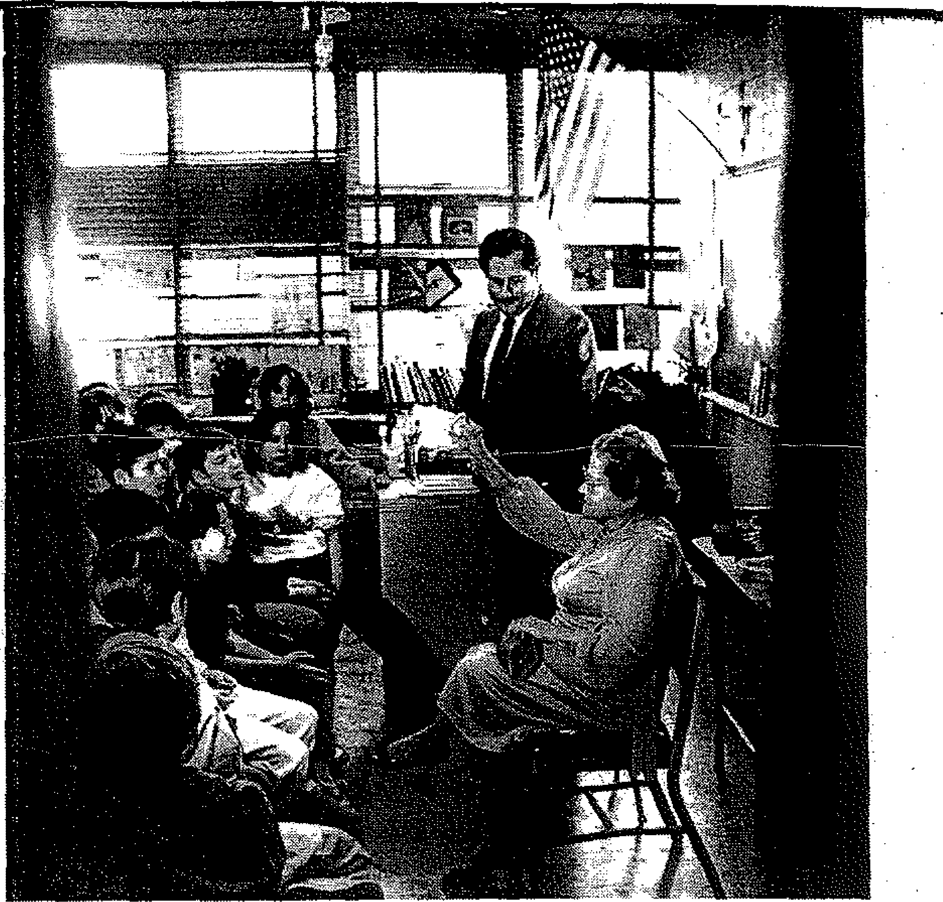

Sharing Stories Of Immigrant Life
By Gwen Young
Plainview - Like so many other grandmothers, Lillian Mordecai Fogel has family tales to telL Tales of her life as a child in Russia, her family's struggle to come to the United States and their joy when they finally reached Ellis Island in 1923.
While memories like these are often lost with passing generations, Fogel took steps to make her memoirs permanent. In a white loose-leaf binder encased in clear plastic, the highlights of Fogel's life, from childhood to gtandmotherhood, unfold on 59 double-spaced, typewritten pages.
There are tales of arranged marriages, of the boat trip from the Soviet Union, of Sabbath dinners, philosophies of raising children and the loneli­ ness of growing old.
After writing with the help of a friend, Marjorie Wolfe of Syosset, the stories she has told for years, Fogel, 85, decided to share her personal. histo- ry with others. Yesterday, dressed in a lace-trimmed lavender dress and black patent pumps, Fogel met 40 fifth-grade students at the Plainview-Old Bethpage Middle School who had read some of her stories. Wolfe, who teach- z es there, had introduced the manuscript to two other teachers. After read-
ing the stories, the students invited Fogel to their classes. g
The stories they read had piqued their curiosity. How long was the boat ► ride? "Three weeks." What was it like when you came to Ellis Island? "It.--< was a dream that you never dreamed could be true." Her voice was barely }l audible, so the children leaned foward in their chairs to hear. With the help 0 of her son, Rabbi Daniel Fogel, who presides at the North Shore Synagogue ·
in Syosset, she was able to tell her tales. . ·;;::: Fogel and her family lived in cramped cabins in a section of the boat that :,,. had no windows, and she was the only one who didn't get seasick. They were --< allowed to bring only the barest necessities, and even their beloved Torah 5-'
'°
was left behind.
a,
Daniel Fogel tried to help the children understand the sacrifices his '-" mother and her family made in traveling to the United States. "Can you imagine leaving your home with almost nothing?"
After the questions and answers, the children·gave Fogel a small bouquet of flowers that 1J1B.tched her dress. Encircled by a group of young girls, she gave them all grandmotherly kisses. Before leaving, she donated $18 to Ellen Smyle's and Elinor Froehlich's fifth-grade students for their Statue of Liberty Restoration collection. ·The amount, chai, the rabbi said, means "life" in Hebrew.
Together, the Fogels urged the children to ask someone in their families to write down the family story. Adam Aw.eg, 11, said he would ask hie great-grandmother Ida todo that."Then she could become famous, like Mrs. Fogel, and she could come to the school," he said.



